|  |  |
| --- | --- |
| PDPM  Indian Institute of Information Technology, Design and Manufacturing, Jabalpur  Domestic Electricity Bill Monitoring | |
| Design and Fabrication Project Report |

Instructors:

Mr. Awadesh Kumar Singh

Mr. K.K.BalaKrishnan

Dr. Amarnath

By

GROUP-47

D GIRISH (2011188)

DEEPAK KUMAR (2011190)

K AVINASH REDDY (2011251)

KAMATHAM SRINADH (2011197)

VELURU JAYAVANTH REDDY (2011233)

### Preface

We are very thankful to our instructors Dr. Amarnath, Mr. K K Balakrishnan and Mr. Awadesh Kumar Singh for giving this wonderful opportunity.

We are also thankful to our Technical Assistants Mr. Bipratim Saha, Mr. Bevin Hector D’cruz, Mr.Rohith Singh and Ms.Rupa for their immense support and motivation for this project.

We are thankful to MPSEB (Madhya Pradesh State Electricity Board), APSPDCL (Andhra Pradesh Sothern Power Distribution Company Limited) and APCPDCL (Andhra Pradesh Central Power Distribution Company Limited).

We are also thankful to people of Jabalpur, and different parts of country for providing their valuable feedback on our survey without which this wouldn’t happen.

D GIRISH (2011188)

DEEPAK KUMAR (2011190)

K AVINASH REDDY (2011251)

KAMATHAM SRINADH (2011197)

VELURU JAYAVANTH REDDY (2011233)

Table of Contents

Preface 1

1. Abstract 3

2. Introduction 3

3. Problem specification 4

3.1 Sub problems 5

4. Objective 5

5. Need Statement 5

6. Product Specifications 5

6.1 Qualitative specifications 6

6.2 Quantitative specifications 6

7. Concept Generation 7

7.1 Concept-1: 7

7.2 Concept-2: 8

7.3 Concept-3: 9

7.4 Concept-4: 10

8. Concept Evaluation* 11

9. Embodiment Design 14

9.1 Detailed Design 14

9.2 Parametric Design 15

9.3 Configuration Design 15

9.3.1 Energy measuring unit 16

9.3.2 Meter Interfacing Unit (MIU) 18

9.3.3 Communication Unit 19

9.3.4 Display unit 20

9.3.5 Tamper Detector 20

9.4 Exploded view 21

9.5 Material selection: 22

9.6 Ergonomic Factors: 23

10. Prototype 23

10.1 Mechanical Part 23

10.2 Electrical Part 24

12. Result 25

13. Components 27

14. Description of Components 27

15. Manufacturing Process 36

16. Modes in Display Provided 38

17. Message Formats 40

18. Database 41

19. Android App 42

20. Conclusion 43

20.1 Advantages 43

20.2 Limitations 43

20.3 Scope 43

21. References 44

Appendices 45

### 1. Abstract

Our Project focuses mainly on the automation in generating electricity bill, which provides various features like daily updates, tamper detection, power cut information.

The GSM technology has become an essential utility in our life. Everybody has got easy access to it. So, there are a numerous products in market which use this technology and send alerts (alarms) by sensing the emergencies. But, we identified that GSM technology has a scope in electricity bill monitoring which can be used to send messages to users about daily usage and also update database of electricity board by sending statistics.

So, we are intended to design a device (product), which can serve above specified purpose.

To reach our aim objectives we brainstormed various concepts with different mechanisms to find the feasibility and further finalized one of them. We came up with some creative concepts which we detailed with the help of CAD software. Out of these concepts we shortlisted one final concept based on its value proposition. The value was evaluated based on some essential requirements of the device.

After finalizing the concept the technical and aesthetic detailing was completed and finally the design is prototyped. The fabrication was also considered while designing the concepts because the manufacturing cost and relative market cost is the basic factor which will govern the success and user satisfaction of the device.

### 

### 2. Introduction

The present electricity bill generation is done manually. It’s highly Person dependant. Human errors cannot be avoided. Billing done mainly on estimated/monthly average basis. In rural areas billing is delayed due to lack of manpower.

Meter data is the only data which is used for billing, it cannot help in analysis like demand analysis, energy audit, pinpointing losses, etc.

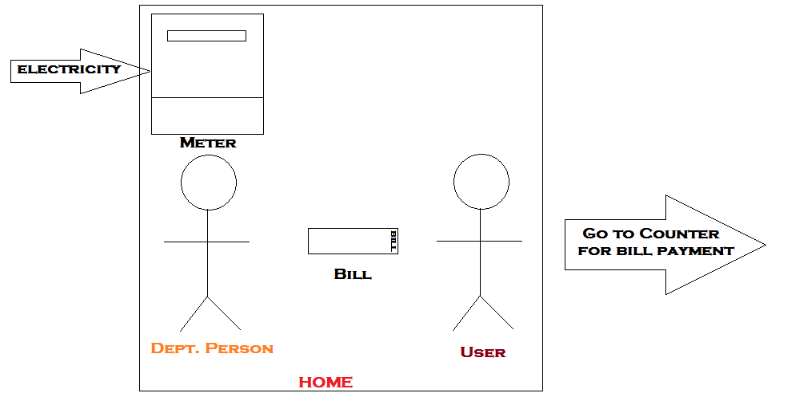

**Fig. Present day system**

### 3. Problem specification

To Generate Electricity Bill, Person must go door to door which delays the process and requires more manpower.

#### 3.1 Sub problems

* In Villages there are many delays in issuing bill, which makes it difficult for people to pay the bill in time.
* Most of the people pay their bill in cash for which they have to wait in long queues.
* Now a days we can see Theft of Electricity in large scale, which causes great loss to the electricity department.
* In villages disconnecting the connection is difficult as they threaten the person who come to disconnect connection.

### 4. Objective

The main objectives we have set to achieve through the device are

* Reduce Human effort

No person is required to go door to door from issuing a bill.

* Daily updates

Information About daily usage will be sent to the user.

* Reduction of Paper work

Text messages are used instead of paper for issuing a bill. This reduces usage of paper in turn saving trees there by maintaining environmental balance.

### 5. Need Statement

*“To device a system that can send alerts about Daily Usage,Monthly Bills and Other info like powercuts etc to the user and update stats of Electricity Department.”*

### 6. Product Specifications

* Freeduino Board
* Daily alerts should be sent to atleast one mobile.
* 12 V DC.
* Digital electricity meter.
* Simcard- full size – 2G/3G – 64Kb.
* GSM Module.
* MAX232 IC.
* 3 X 200W bulb(used as load).
* Capitors,Resistors,Diodes.
* Processing unit.
* Proximity sensor.
* 16 X 2 LCD Display.
* Working temperature: -10°C to 80°C.
* Relative humidity: 10 to 90%.No condensation.

#### 6.1 Qualitative specifications

1. Easy to interact interface.
2. Capability to with stand high temperatures (at least of for a short span) when used during a fire break-out.
3. Robust enough to withstand impacts when dropped from heights about 6 feet.
4. Must be reliable.
5. Low power consumption when on stand by and when triggered.
6. Should be easy to mount on walls and should rest properly on horizontal surfaces.
7. Stray electric and magnetic fields should not affect / disturb the device.

#### 6.2 Quantitative specifications

1. Battery backup of more than 12 hours.
2. Daily alerts should be sent to atleast one mobile.
3. Size of the device should be less than 8X8X8 inch.

### 7. Concept Generation

#### 7.1 Concept-1:

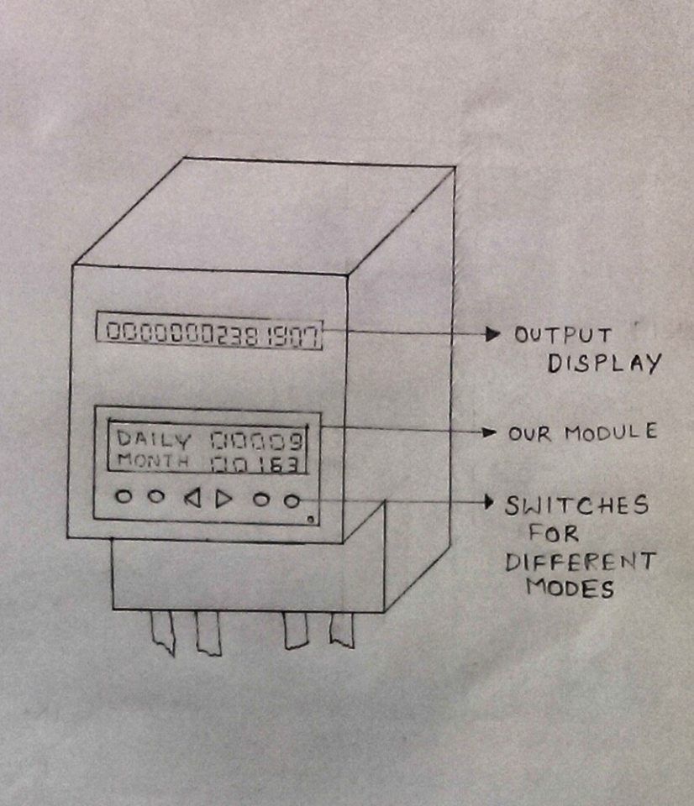

**Fig. Concept-1**

In this concept, we have to change the design of the meter. There are two displays in this meter, one the default display and the other show the daily updates, monthly updates, cost per unit etc. in different modes. To change these modes buttons are provided below the second display. These buttons are designed in such a way that they are easy to navigate.

#### 7.2 Concept-2:

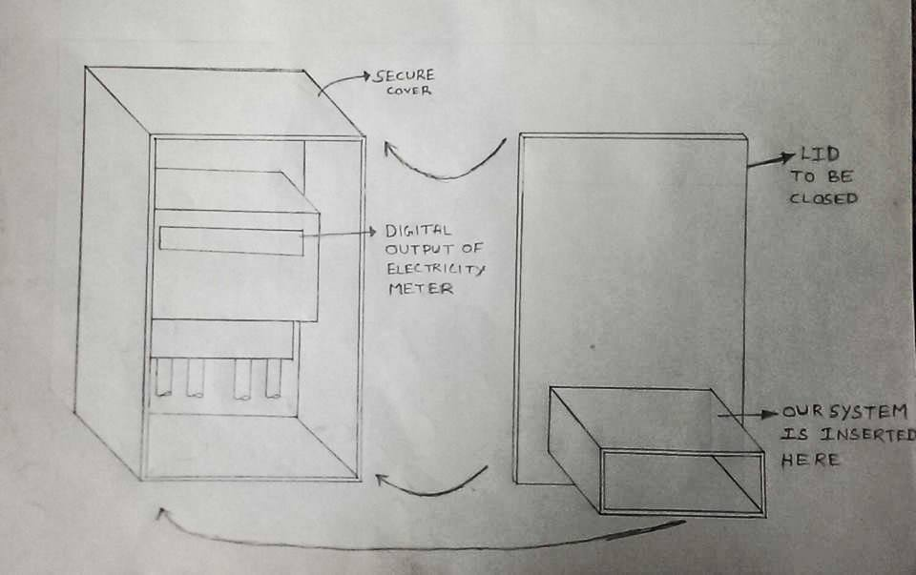

**Fig. Concept-2**

In this concept, the design of the meter is not changed. A separate unit with its own display is connected to the present day meter. This unit takes input from the meter and calculates the no of unit consumed per day and also keeps track of the no of units consumed in that month. These two components are enclosed in a box for extra protection in bad weather conditions in villages.

#### 7.3 Concept-3:

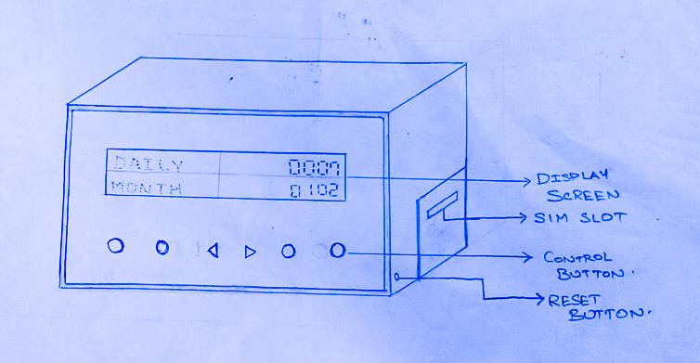

**Fig. Concept-3**

In this design, a portable device is made to communicate with the meter either wired/wireless. This displays the updates and can remotely fixed anywhere in the house. It will be simple in its design and its user friendly. This design is mainly useful for the people, who stays in apartments and communities where meter can’t directly seen by the user. It can be fixed on MSB (usually present at the close proximity to the user) and access it.

#### 7.4 Concept-4:

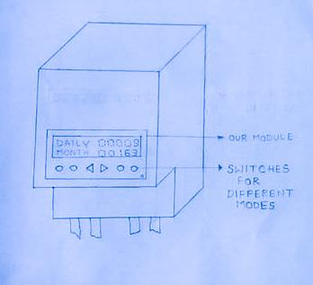

**Fig. Concept-4**

In this concept only one display is provided which shows the updates. This makes it easier for manufacturing and also easy for the user to see the details. If any problem occurs in the device, the department people will have a separate device for error checking and other things.

### 8. Concept Evaluation*

|  |  |  |  |  |  |
| --- | --- | --- | --- | --- | --- |
| S.No | Parameters | Concept-1 | Concept-2 | Concept-3 | Concept-4 |
| 1 | Size | 7.4 | 6.4 | 6.6 | 7.8 |
| 2 | Portability | 2 | 2 | 8.2 | 2 |
| 3 | Weight | 7.2 | 6 | 7.4 | 7 |
| 4 | Ease in operation | 7.8 | 7 | 8.4 | 7.6 |
| 5 | Aesthetic appeal | 6.8 | 6.8 | 7.6 | 7.8 |
| 6 | Reliability | 7.4 | 7.6 | 7.6 | 7 |
| 7 | Precision | 5.2 | 7.2 | 6.8 | 5 |
| 8 | Installing Cost | 6 | 7.2 | 5 | 6.4 |
| 9 | Ease in installation | 6.2 | 7 | 7.2 | 6.2 |
| 10 | Durability | 6.2 | 9 | 6.4 | 6.4 |
| 11 | Ease in repair | 6 | 7 | 7.6 | 5.8 |
| 12 | Ease in Manufacturing | 7.2 | 8.2 | 7 | 7.2 |
| 13 | Power consumption | 7.2 | 7.2 | 5.8 | 7.6 |
| 14 | Recurring cost | 7.6 | 6.4 | 6.4 | 7.4 |
|  | TOTAL | 76.6 | 95.0 | 97.0 | 91.2 |

*ratings are the average of individual ratings given by team

So as per our evaluation our concept-3 is finalized as it is portable, requires less amount of installation charges and can be manufactured easily. Its cad model is shown below

D:\cad photos\assembly1.tif

**Fig. CAD Model of final Concept**



**Fig. CAD Model Showing internal parts of final Concept**

### 9. Embodiment Design

#### 9.1 Detailed Design

|  |  |  |
| --- | --- | --- |
| Components | Units | Type |
| Digital Energy Meter | 1 | Digital |
| GSM Module | 1 | SIM300 |
| Max232 IC | 1 | - |
| Li-ion Battery | 1 | DC |
| 16X2 Display | 1 | LCD |
| Capacitors | - | Ceramics |
| Resistors | - | - |
| Box | 1 | Acrylic Sheet |
| Screws | - | Mild Steel |
| Wall fixtures | 1 | Aluminium Sheet |
| Box fixtures | 1 | Acrylic Sheet |

#### 9.2 Parametric Design

|  |  |
| --- | --- |
| Components | Parameters |
| Digital Energy Meter | Size: 172X180.5X76(mm) |
| GSM Module | Size: 29X29X3.6(mm) |
| Max232 IC | - |
| Li-ion Battery | - |
| 16X2 LCD Display | Size: 70X23(mm) |
| Capacitors | - |
| Resistors | - |
| Box | Size: 150X100X100 (mm) |
| Screws | - |
| Wall fixtures | 30X5X100(mm) |
| Box fixtures | 30X5X100(mm) |

#### 9.3 Configuration Design

There are five basic units:

* Energy measuring unit
* Meter interfacing unit
* Communication unit
* Display unit
* Tamper detector

##### 9.3.1 Energy measuring unit

Generally power companies will do electricity transmission through transformers. From transformer connection is given to meter and then load is connected to it.

Basically in this unit, it consists of instrument used for measuring power usage. It displays the readings of power usage based load of the electronic devices connected to the meter.

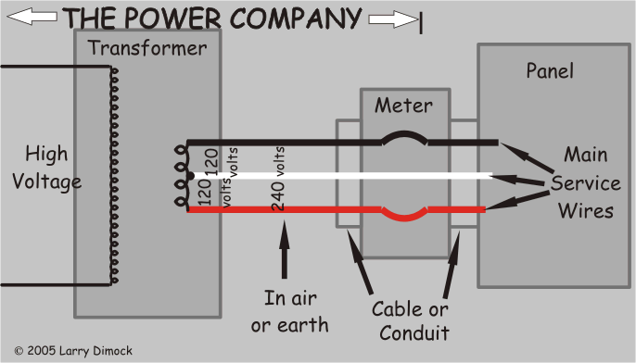

**Fig. Transmission of Power**

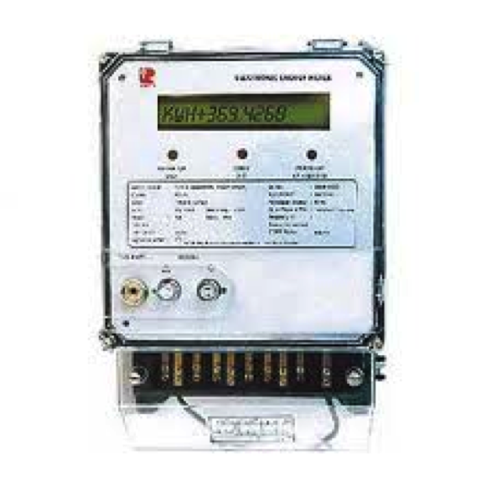

**Fig. Energy Meter**

From the meter the reading will be sent to the meter-interfacing unit, it analyses the data and transfers it to the communication module.

##### 9.3.2 Meter Interfacing Unit (MIU)

This unit is connected to the meter from which the data is received. It consists of a micro controller that can analyze the data received from the meter and sends it to GSM module.

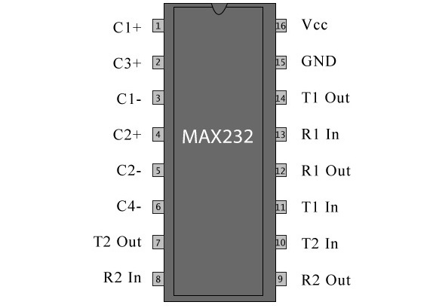

**Fig. Pin Configuration of MAX232 IC**

The MAX232 is an IC, which converts signals from an RS-232 serial port to signals suitable for use in TTL compatible digital logic circuits. It is a dual driver/receiver and typically converts the RX, TX, CTS and RTS signals.

##### 9.3.3 Communication Unit

It is used to send a message to the customer about the usage of electricity. In this unit we use GSM module, which helps in sending message to the customer and updates the data in electricity department server. A GSM module is connected to a microcontroller that would transmit data from a meter to cell phone and also receive commend from cell phone to energy meter. **AT** commands, set which energy meter to communicate with the GSM modem, uses stands for attention terminal.

We need two wires between this unit and microcontroller/Arduino, one for transmission and other for Reception (TX and RX respectively). Using this modem, you can send SMS, data and read SMS through simple AT command.

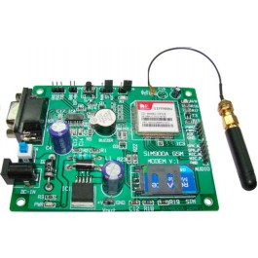

**Fig. GSM Module**

Description: This GSM module is built with the advance SIM300 engine works on frequencies EGSM 900 MHz, DCS 1800 MHz and PCS 1900 MHz .It is very compact in size and easy to use as plug in module. The Modem is coming with RS232 interface, which allows you to connect directly to PC or microcontroller /Arduino.

##### 9.3.4 Display unit

This unit consists of the LCD display in which entire details will be shown.

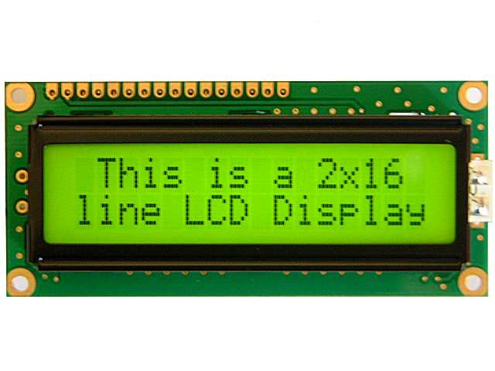

**Fig. LCD Display**

**Liquid crystal display**

A Liquid crystal display are interfaced to microcontroller unit which displays the meter reading, date time, power factor, power status, total load used etc.

##### 9.3.5 Tamper Detector

The entire setup discussed above will be placed in a box in which a proximity senor will be placed inside it. That sensor helps in detecting any occurrence of tampering.



**Fig. Proximity sensor**

Here there will be an IR led which will emit IR rays. There is also an IR receiver, which on receiving of IR rays completes the circuit and sends an indication to the microcontroller. If anybody tries to open the box the IR sensor, which is present inside it, detects it and correspondingly sends a message to the electricity department.

#### 9.4 Exploded view

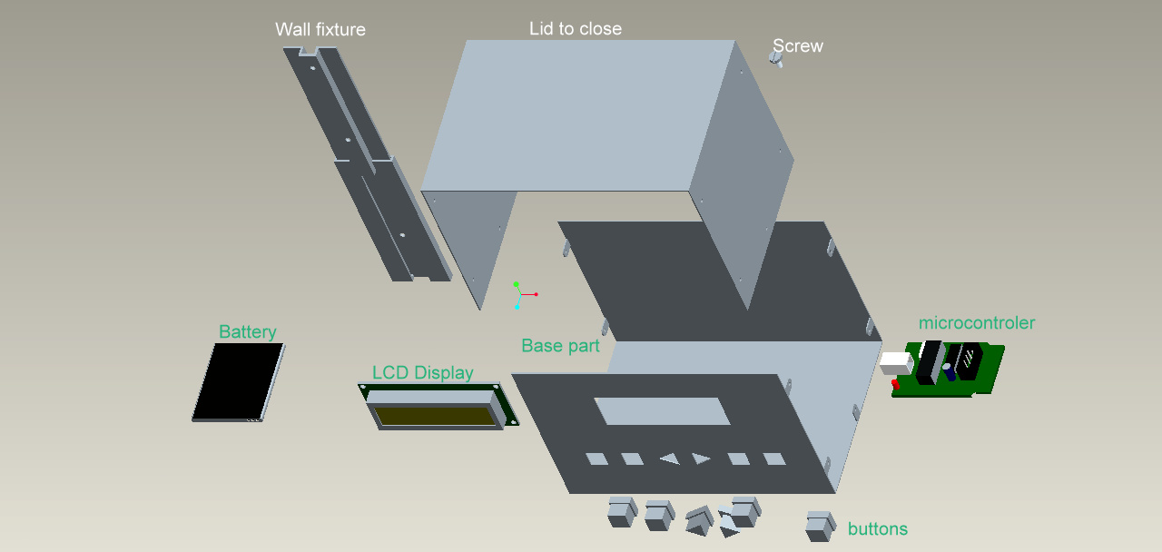

**Fig. Exploded view**

#### 9.5 Material selection:

|  |  |  |  |
| --- | --- | --- | --- |
| Component | Materials/Types Available | Selected thing | Reason for Selection |
| Base part  And  Cover part (Lid to close) | Aluminium | GI sheet | * Optimum Cost * Strength * Durable * Easy Processing |
| Acrylic Sheet |
| Plywood |
| Mild steel |
| GI sheet |
| Wall Fixtures | Aluminium | GI sheet | * Optimum Cost * Strength * Durable |
| Acrylic Sheet |
| Plywood |
| Mild steel |
| GI sheet |
| Buttons | Acrylic Resin(Plastic) | Acrylic Resin(plastic) | * Optimum Cost * No Electrical Conductivity * Availability |
| Synthetic rubber |
| Enamel Brass |
| Display Screen | LCD | LCD | * Minimum Cost * Nature of display * Ease in Availability |
| LED |
| TFT |
| Battery | Li-ion | Li -ion | * Efficiency * Good backup |
| Li-po |
| GSM Module | Sim 300 | Sim 300 | * Optimum cost |
| Sim 900 |

#### 9.6 Ergonomic Factors:

* Color of Display:

Reading should be visible on Daylight and in Dark.

* + - Black Reading with Green Background.
* Reachability:

Device should be placed at a height such children shouldn’t be able to touch it.

* Clearance:

There should be enough Space between buttons for easy operation.

### 10. Prototype

Prototype simulation

1. Mechanical part
2. Electrical part

#### 10.1 Mechanical Part

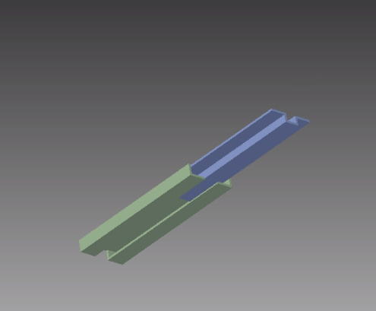

**Fig. CAD model of wall fixture**

We have done a simulation related to our Wall fixtures. In this we showed how to fix the device and remove the device.

#### 10.2 Electrical Part

We have done a simulation related to our electrical circuit part. In this we showed communication between two microcontrollers one which will be connected to the electricity meter and another, which will be in phone/computer. The microcontroller connected to meter will send a message about the units used in that month through the TX pin to the GSM module that we will be using to communicate.

Here we simulated that without using GSM module through a wired connection between we wrote a program to send data at certain intervals of time to the microcontroller that will be connected to the meter. While that of other we wrote a program to receive the data send by other microcontroller and display it in the LCD (16x2) interfaced to it. Here is a screen shot of that simulation. Here the data send by first microcontroller is ‘53’ as the second microcontroller is displaying the same in the LCD interfacing to it.

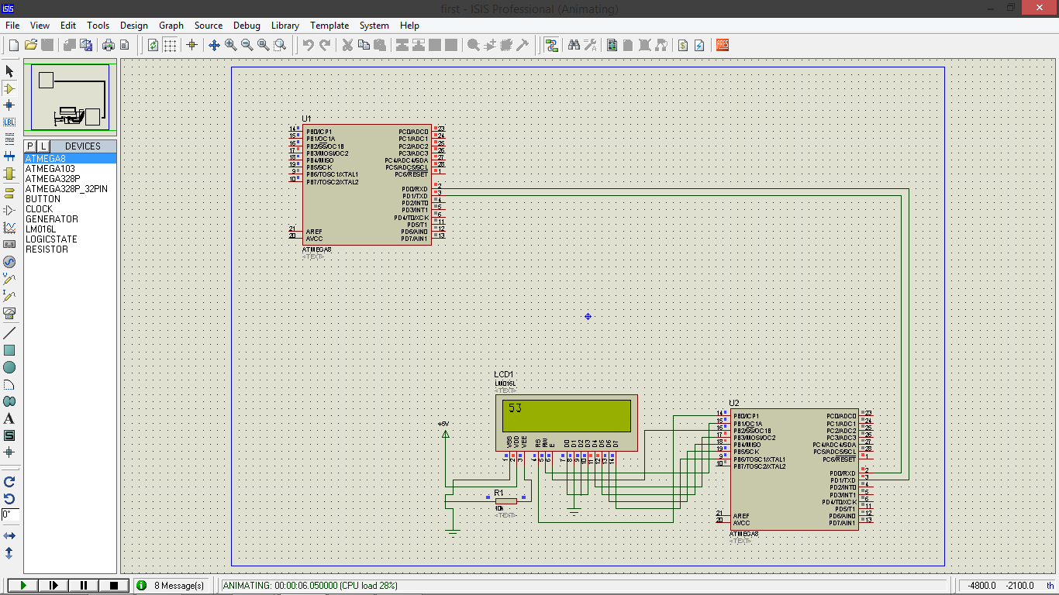

**Fig. Snapshot of Electrical simulation**

### 12. Result

We developed a system using the above mention methods which is as follows. It will solve our main problem and the sub problems also.

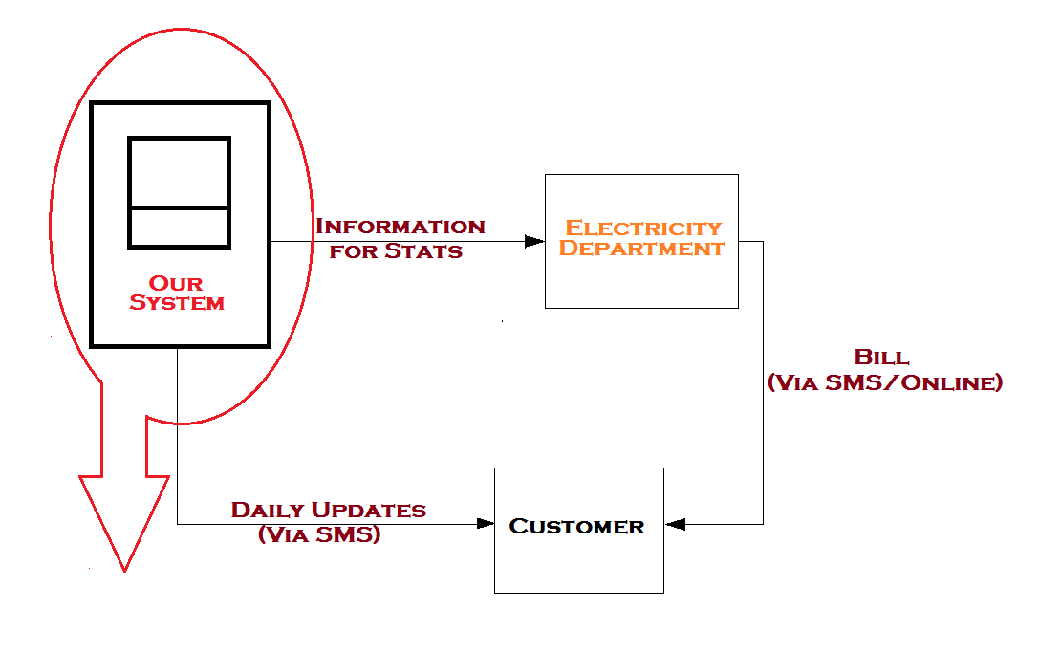

**Fig. Workflow of Device**

**Fabrication Phase**

By taking various factors into account, we came to our final design concept for which we require the following components:

### 13. Components

* Energy Meter
* Light Detecting Resistor
* Microcontroller (Freeduino Board)
* GSM Module
* Power source
* 16 X 2 LCD display
* Buttons
* Development boards
* Box for protection
* Load (Bulbs with Holders and Switches)

### 14. Description of Components

**Energy Meter:**

For our project, we are using a Klick Energy meter. This meter calculates units of power utilized in **kilowatt-hours**. There is a LED, which blinks for **3200 pulses** for every single unit of power utilized. These light pulses are taken as input to the microcontroller with the help of LDR (Light Detecting Resistor).

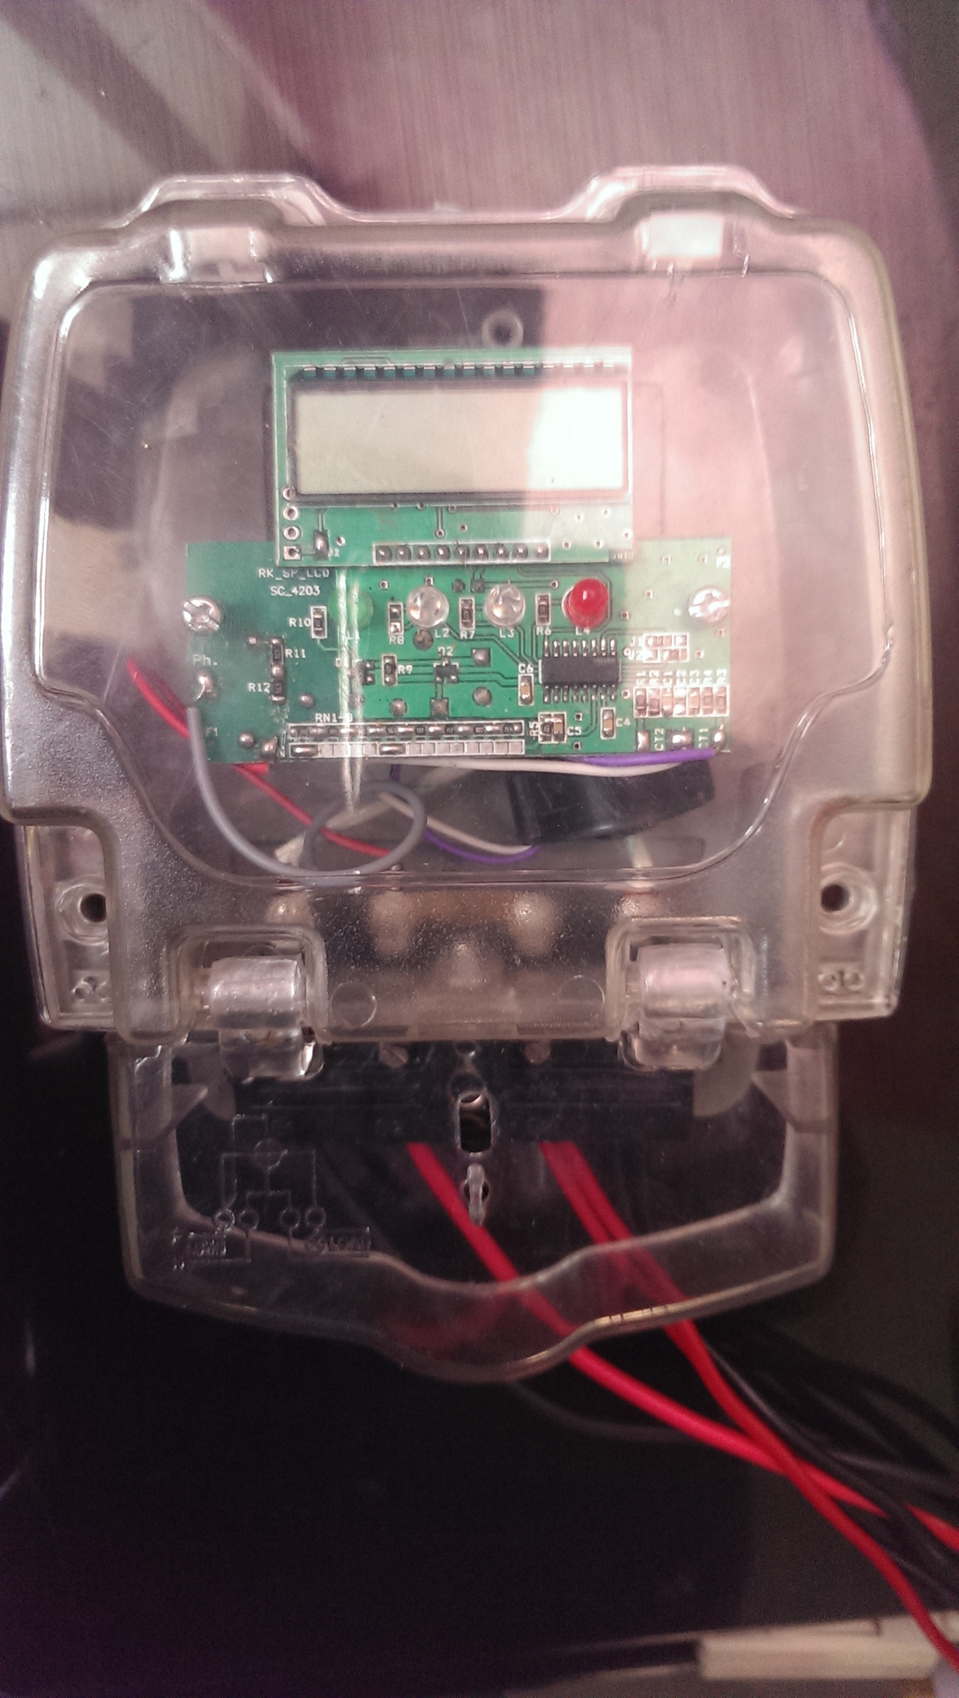

**Fig. Energy Meter**

Specifications:

* Meter type: Digital, AC Single Phase 2 Wire 240 Volts
* Current Range: 5-20 Amperes

Criteria for Selection:

* Digital Meter
* Low in Cost

**Cost:** INR 450

**LDR (Light Detecting Resistor):**

The best part in our project is use of LDR, because when we use LDR there is no need of opening the energy meter (which is treated as tampering) at the time of installation of our device.

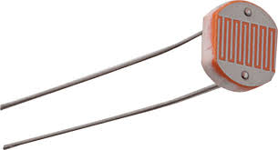

**Fig. Light Detecting Resistor**

Criteria for Selection:

* Easy Usage.
* Effective Measuring.

**Cost:** INR 10

**Microcontroller (Freeduino Board):**

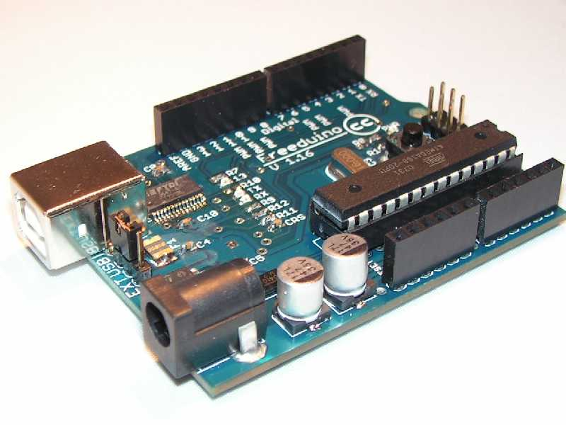

**Fig. Freeduino Board**

We are using freedino board as our microcontroller, which is much reliable compared to other microcontrollers at optimal cost.

Specifications:

* ATMEGA 328 IC
* Input: 9V, 0.5-1 Ampere Current
* Output: 5V
* Timers and Counters

Criteria for Selection:

* Optimal cost.
* Easily Programmable using Arduino software.

**Cost:** INR 850

**GSM Module:**

For our project, we are using a SIM900 GSM Module, which is used for communication purposes with other devices.

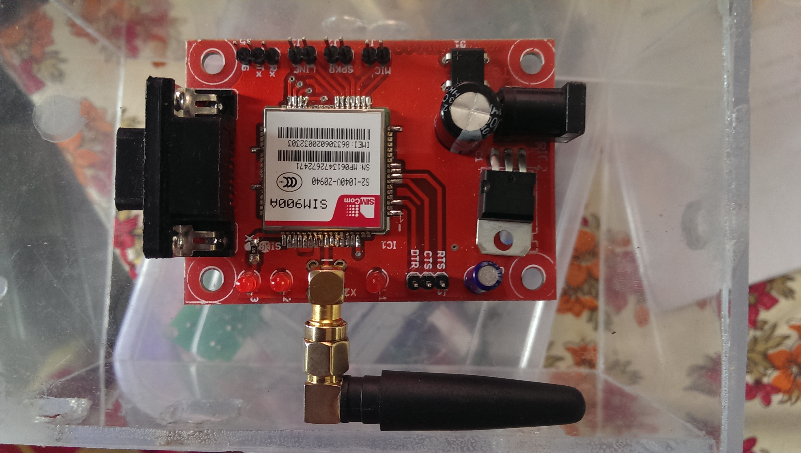

**Fig. GSM Module**

Specifications:

* + Dual band GSM/GPRS 900/1800MHz.
  + Configurable baud rate.
  + Built in network status LED.
  + Inbuilt powerful TCP/IP protocol stack for Internet data transfer over GPRS.

Criteria for Selection:

* Communication purpose.
* Easy Programming.
* Inbuilt MAX232 IC.

**Cost:** INR 1450

**Power Source:**

For our project, we are required to use power, for this we are using adapters.

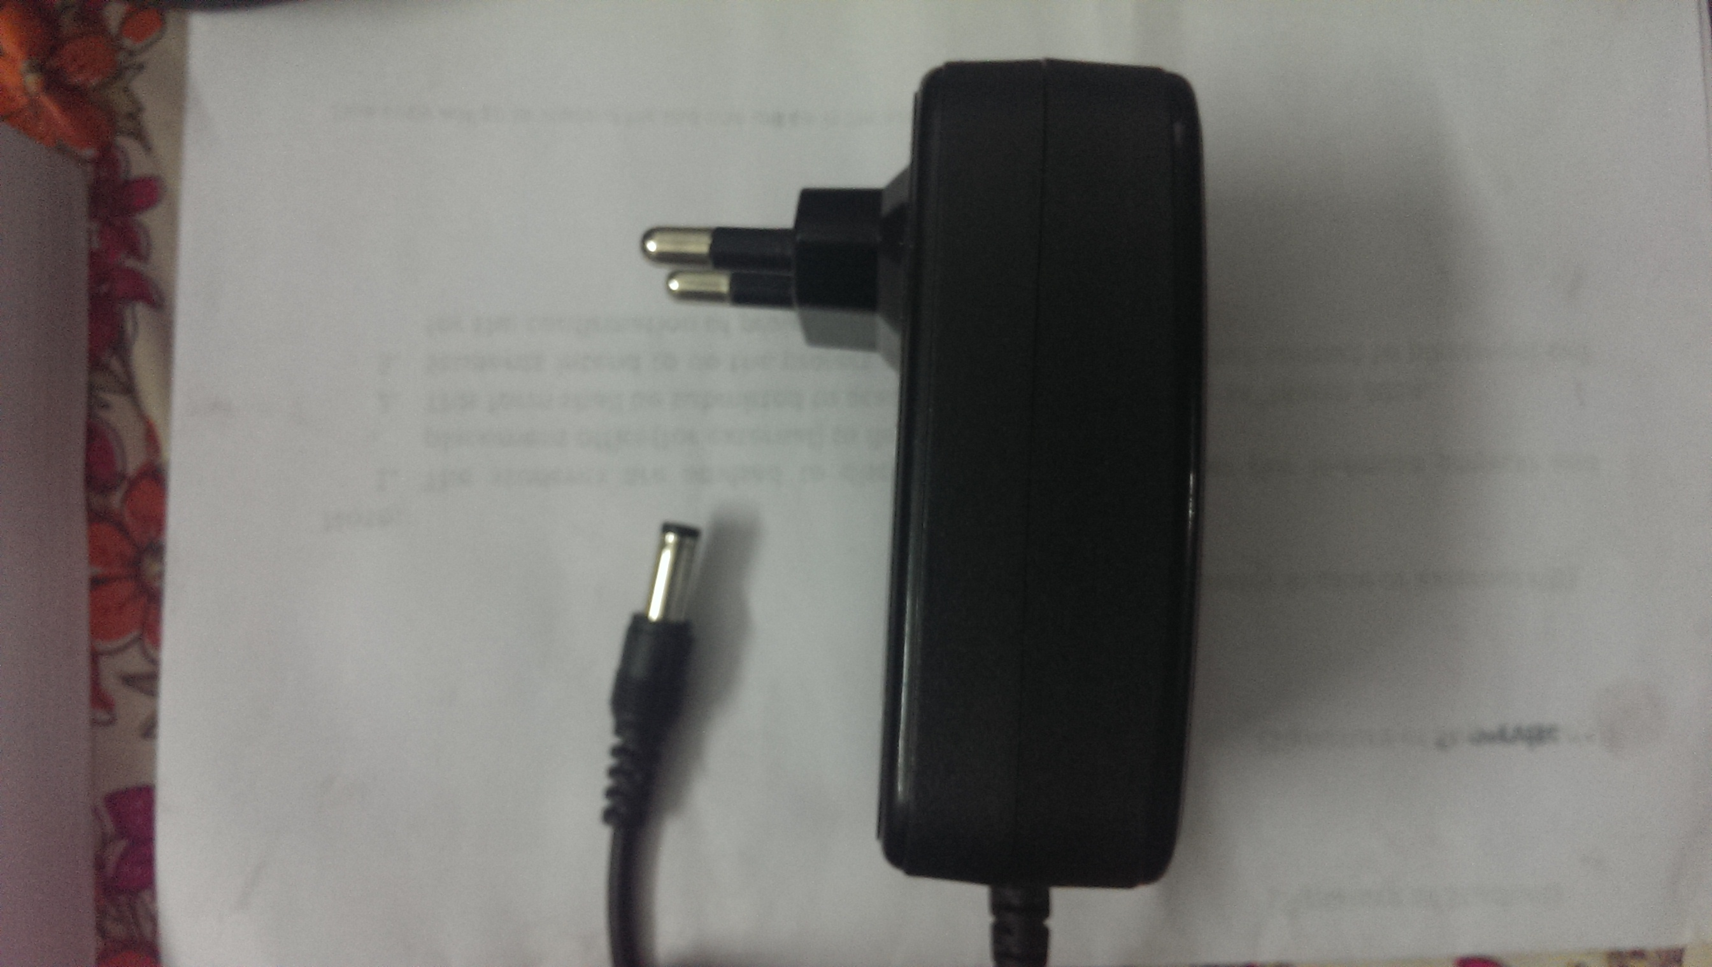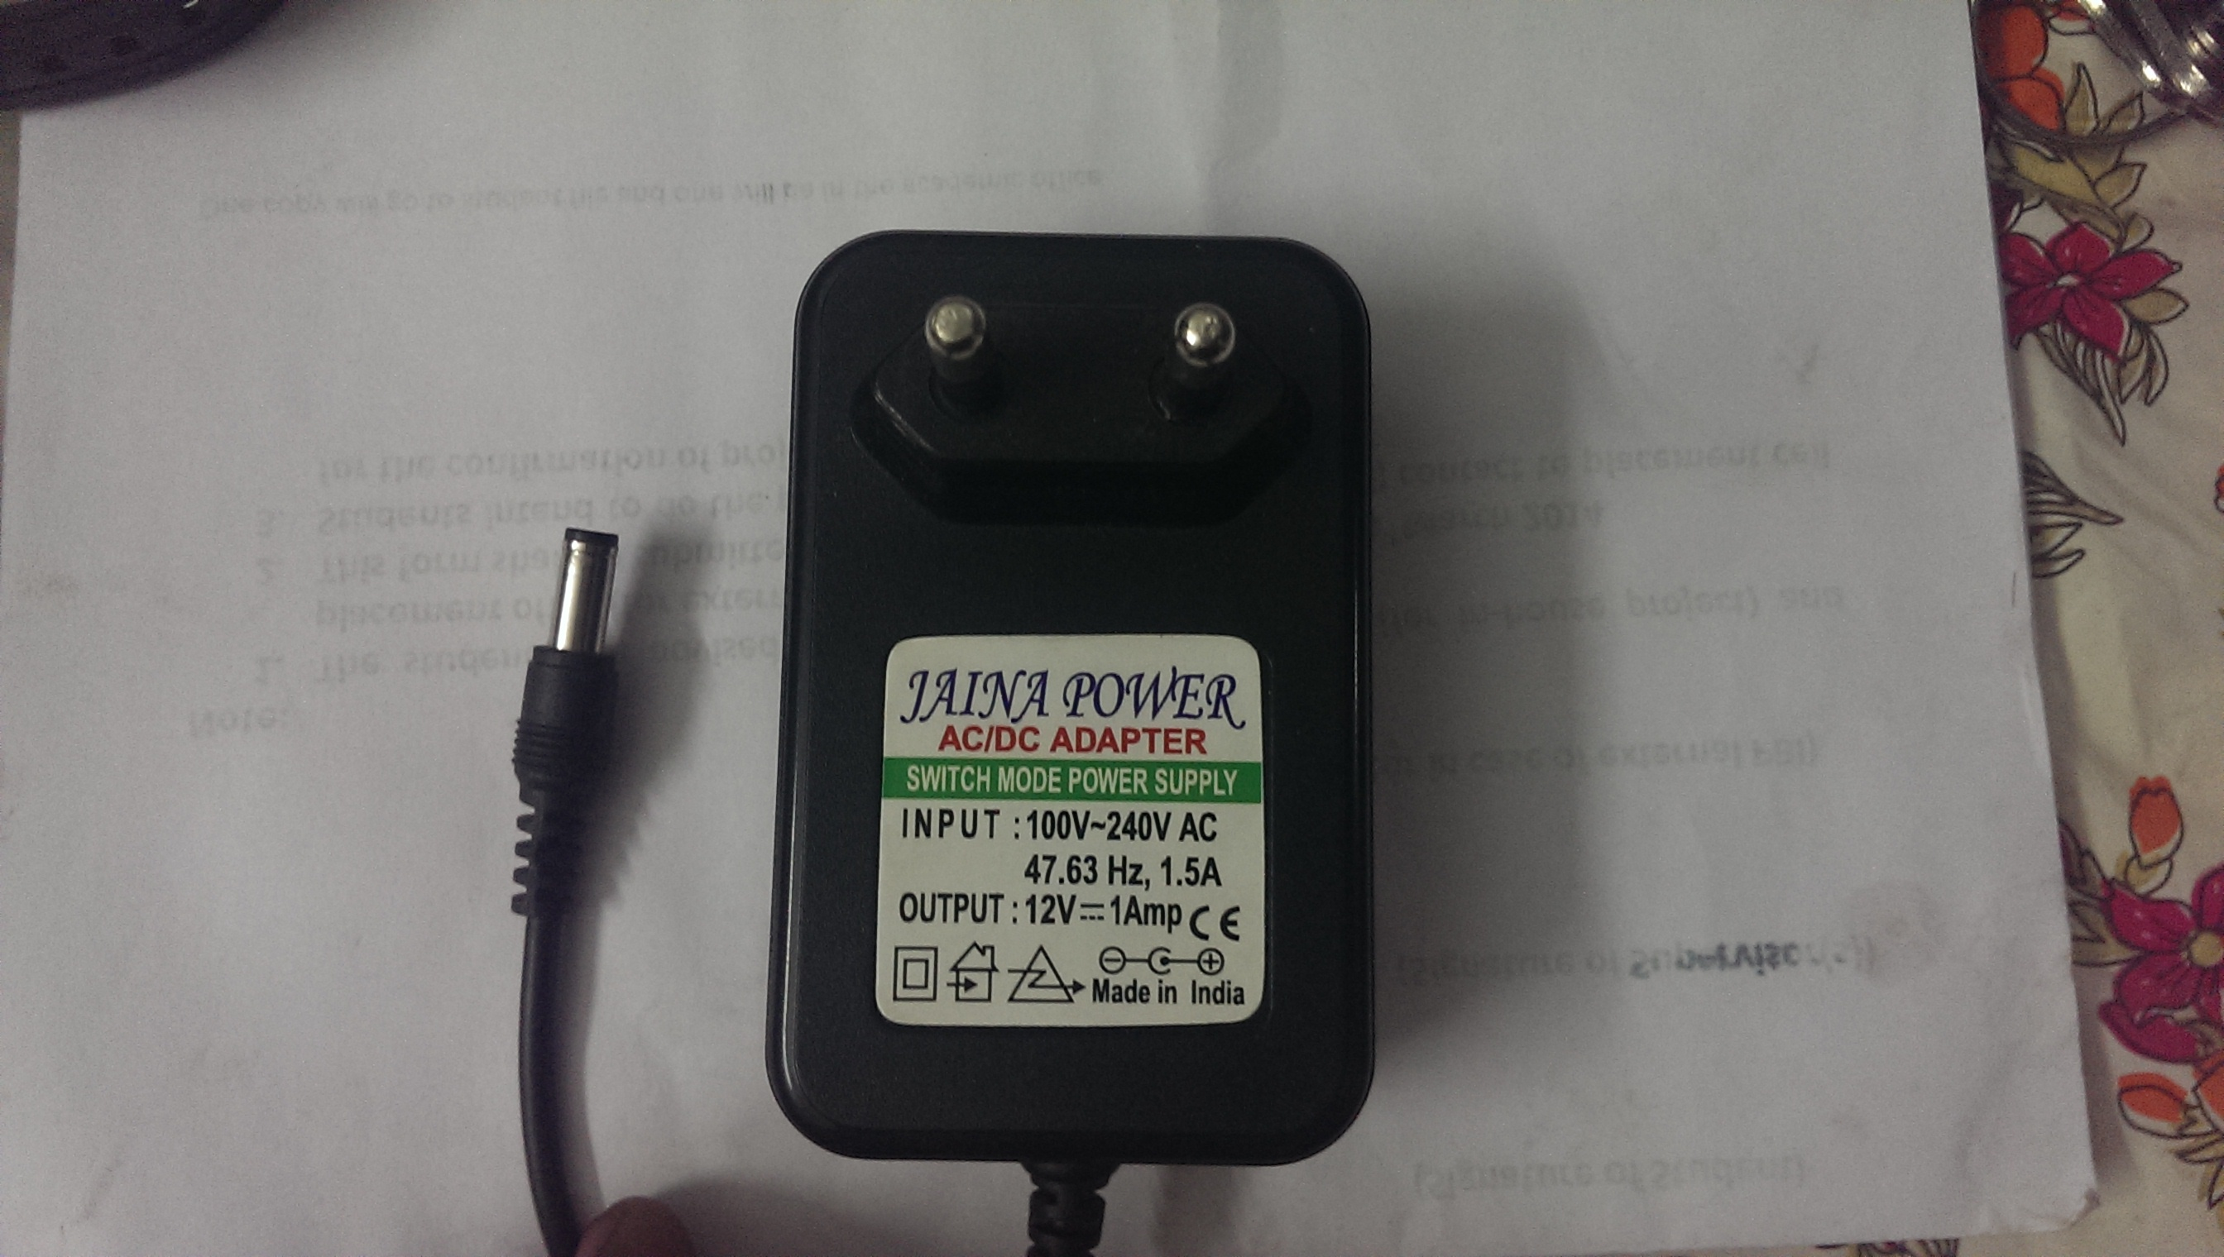

**Fig. Adapters**

Specifications:

* Input: 100v -240V AC
* Output: 12V=1Ampere Current

Criteria for Selection:

* 1 Ampere Current source is required.

**Cost:** INR 170

**LCD Display:**



**Fig. LCD Display**

In our project, we are required to show units consumed by the user in different ways, for this we require to have a LCD display.

Specifications:

* 16 X 2 alphanumeric display.

Criteria for Selection:

* Displays different modes.

**Cost:** INR 170

**Buttons:**

In our device, we are providing different modes of displays for the customers, which can be controlled by buttons provided on the device itself.

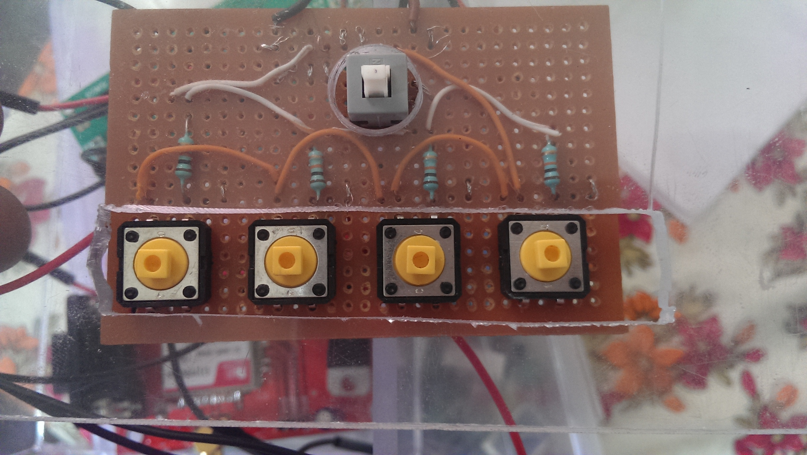

**Fig. Buttons**

Specifications:

* Quantity: 4

Criteria for Selection:

* Setting modes.

**Cost:** INR 40

**Box:**

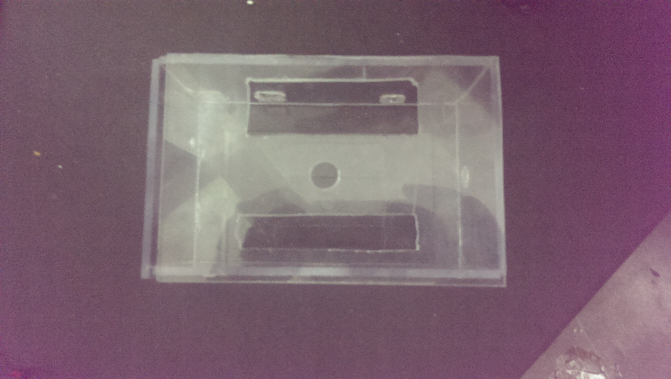

**Fig. Box**

Our circuits and other development boards kept in the box, which is made of Acrylic sheet.

Specifications:

* Size: 100mm X 150mm X 70mm
* Material: Acrylic sheet (Thickness= 4mm)

Criteria for Selection:

* Durable.
* Strong.
* Electrically and magnetically insulated.

**Cost:** INR 150

**Load:**

In our project, we are required to show working of the device, which is done when energy meter reads units consumed by the load given. For this we are using 3 bulbs (200watt each) as load.

### 15. Developing and Manufacturing

**Device:**

Designed a circuit, which consists of components like Freeduino board, GSM Module, which are Rectangular in shape. We are required to make our device, which can hold those components firmly; this is possible if the device is in cuboidal shape. So, we made our device in the shape of cuboid and fixed the complete circuit inside it. Some of the components, which are present in the circuit have sub components like stub antenna for GSM module, power jacks and programming jacks for freeduino and GSM module, which must be available at later time. For all these things we have drilled sufficient holes on the device wherever required.

The front face of the device have been slotted in such a way that it can hold the LCD display, Buttons for operating the device and a button which switches on and off the back light of the LCD display. GSM Module is placed at the right side of the device and Freeduino board is placed at the left side of the device for easy connections in the circuit.

Made the device by attaching acrylic sheets with the help chloroform and also a box fixture for the device, which is made of acrylic sheet and can be attached to the wall fixture.

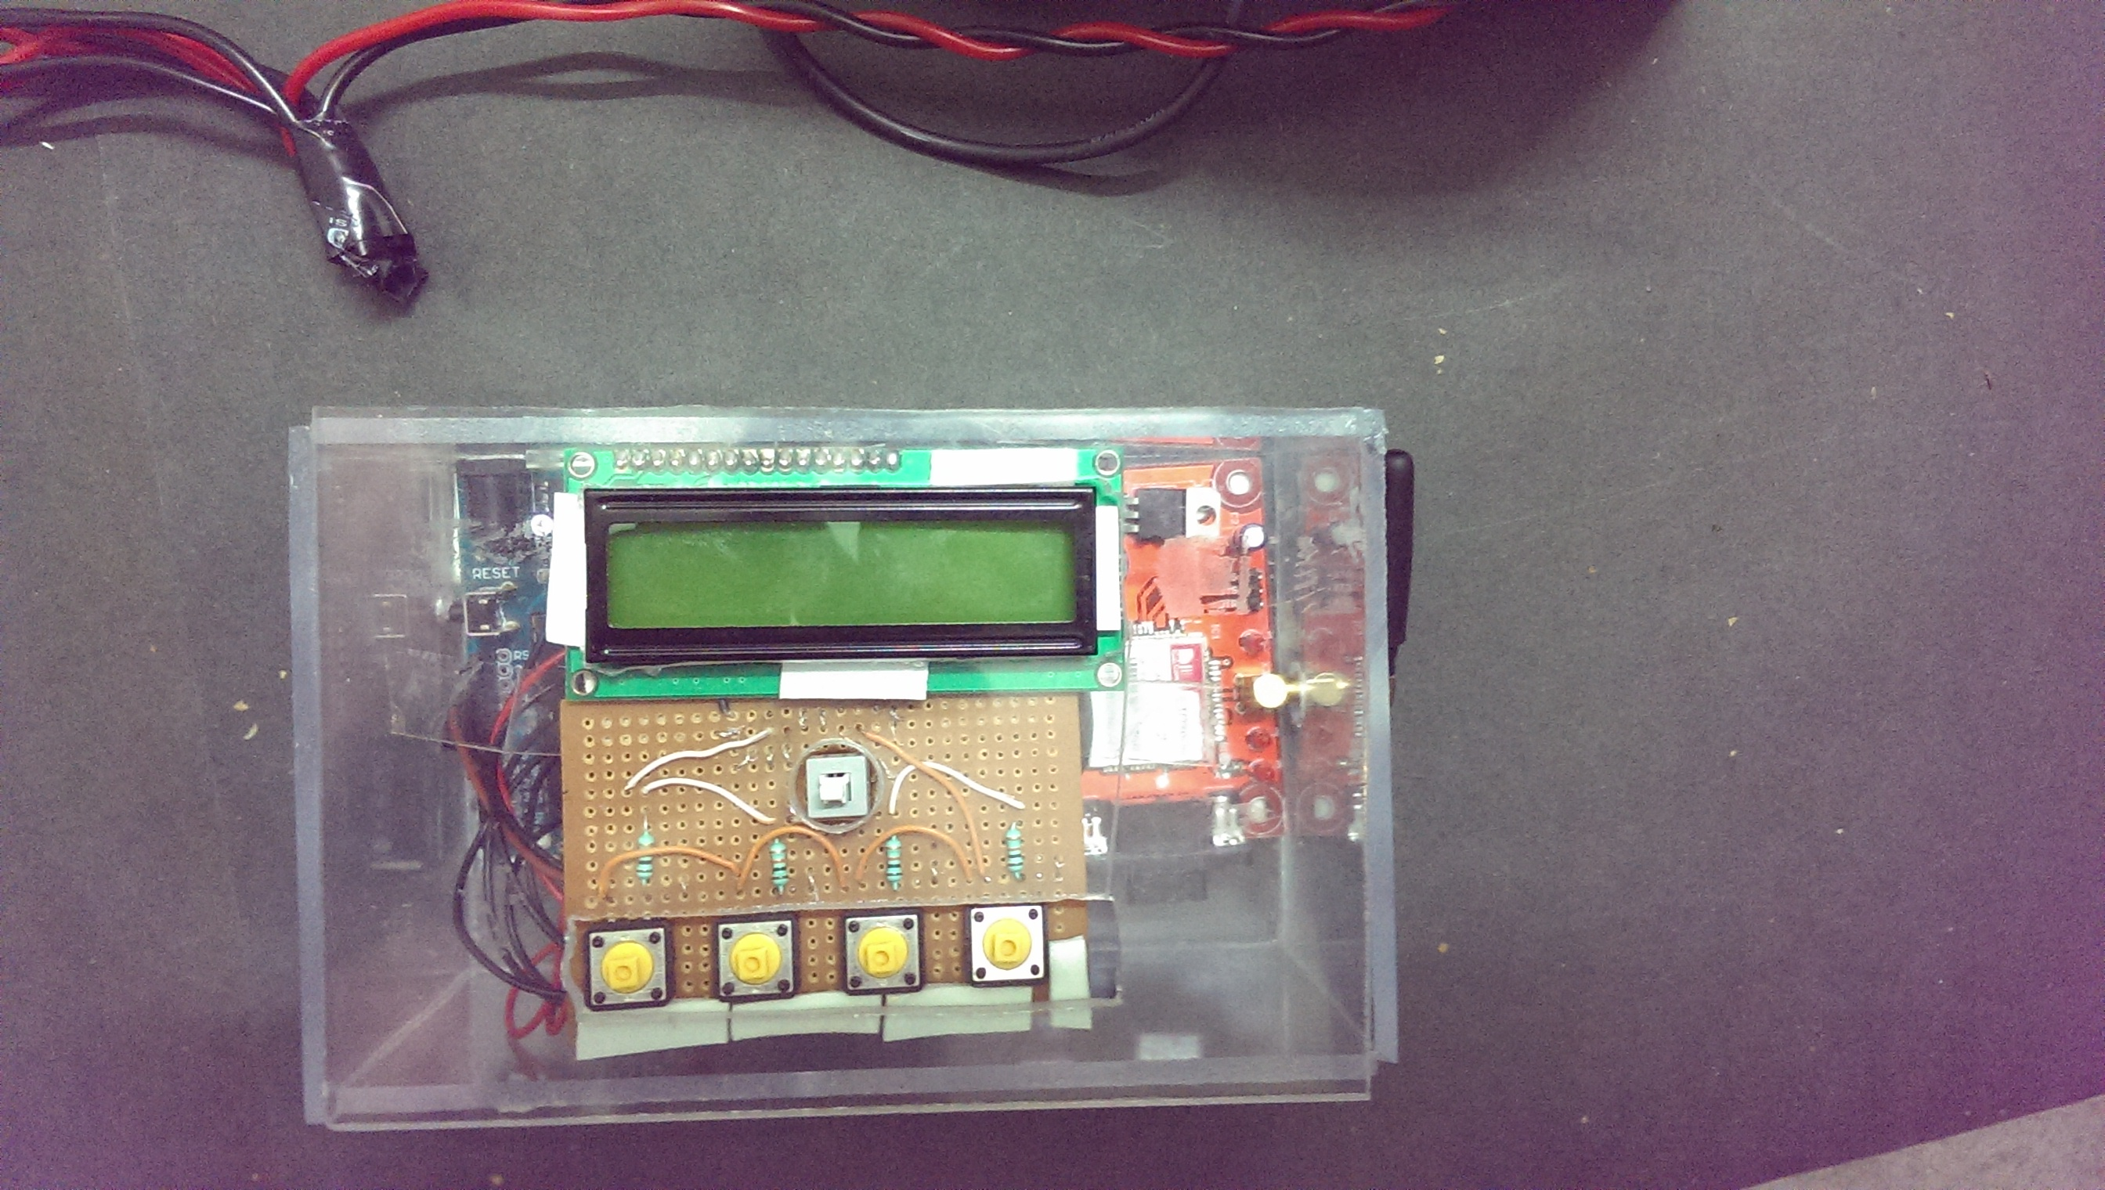

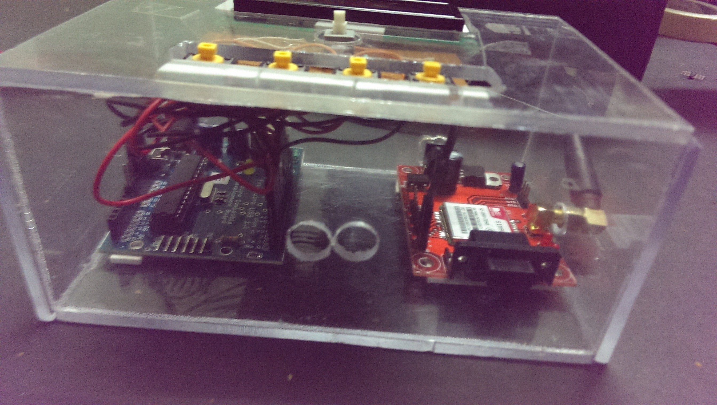

**Fig. Device**

**Circuit:**

We have used components like Freeduino Board, GSM module, LCD display, Switches, LDR, LEDs, some resistors and appropriate sensors as shown in figure.

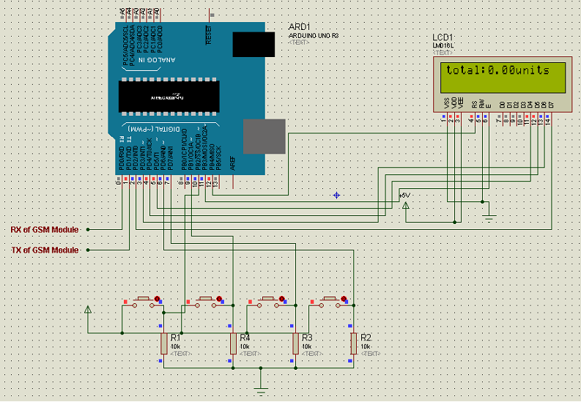

**Fig. Circuit Diagram**

A circuit has a part, which detects the tampering that can occur with the meter, for this a proximity sensor is kept with it. If anybody tries to tamper the meter, the proximity sensor detects the tamper and sends information to database of the electricity department, which further generates a warning message and sends it to the user.

### 16. Modes in Display Provided

Default Display:

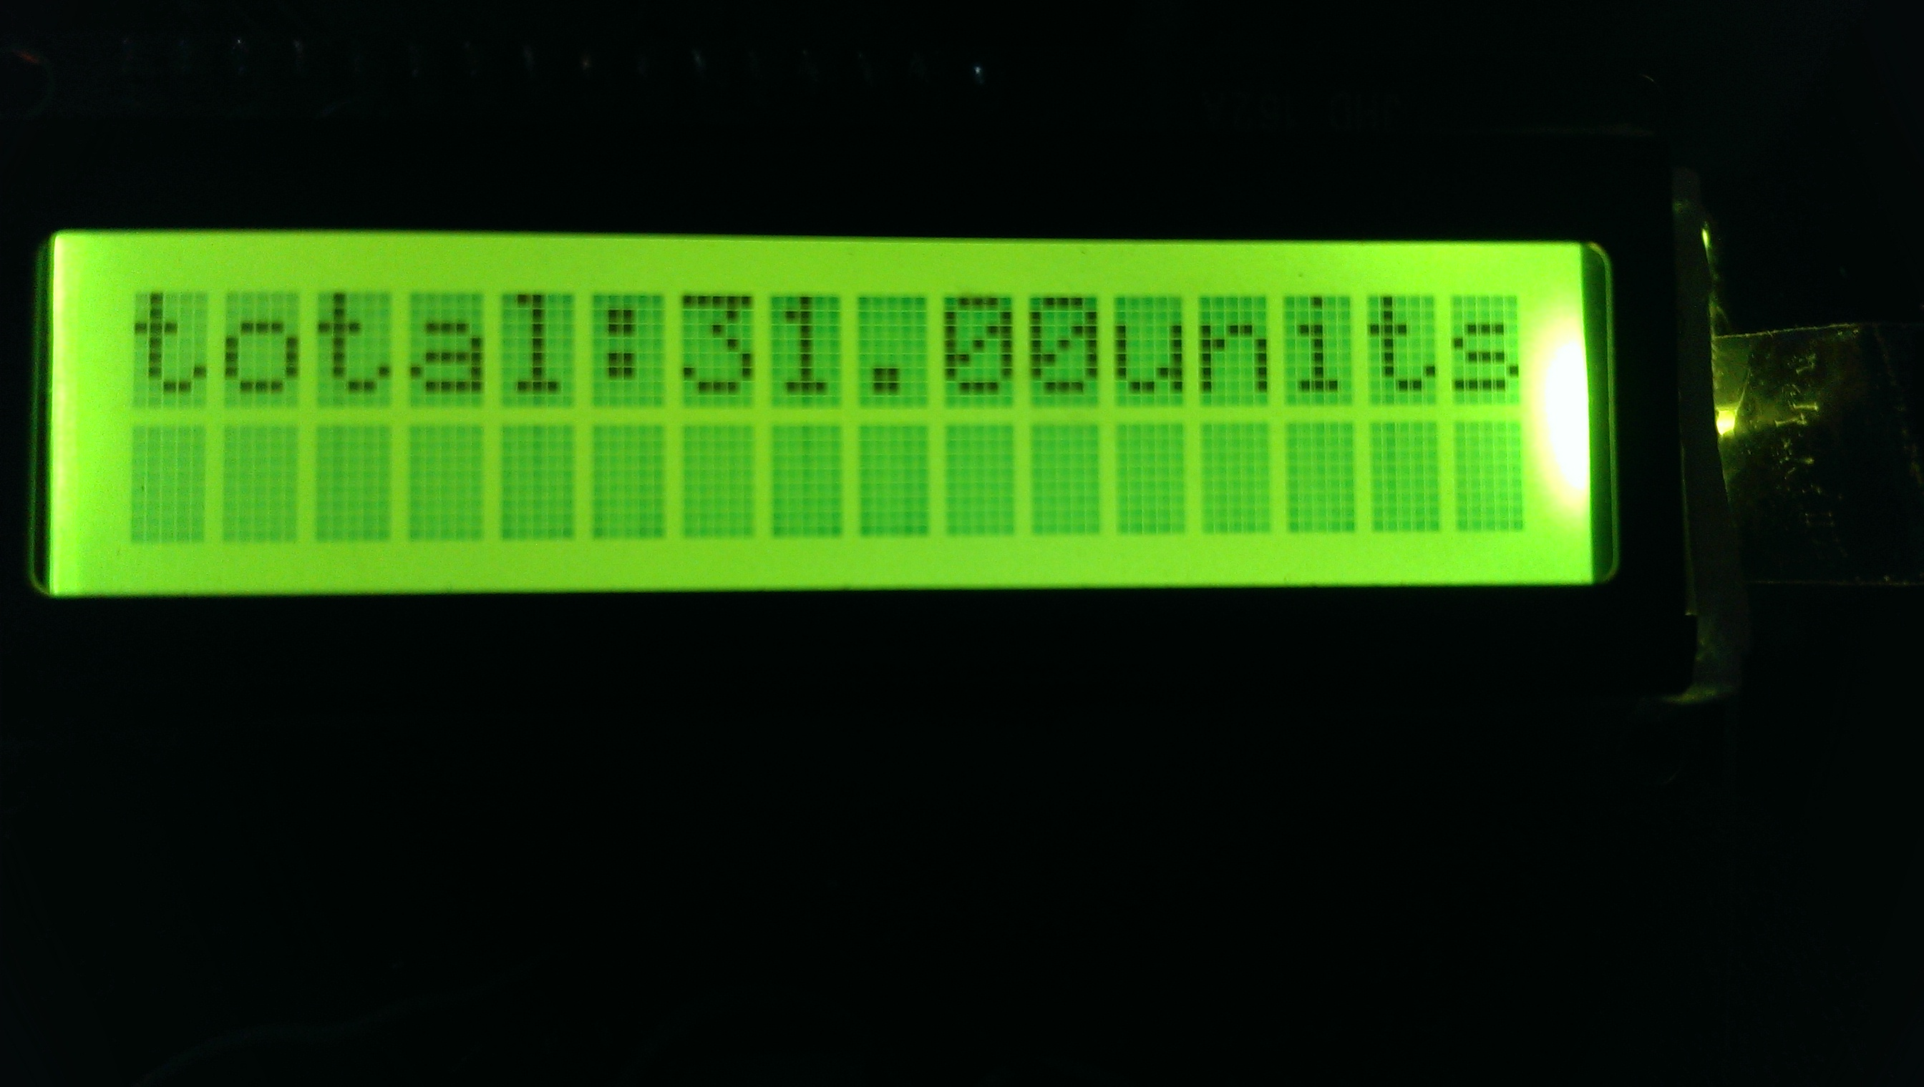

Display while Sending SMS:

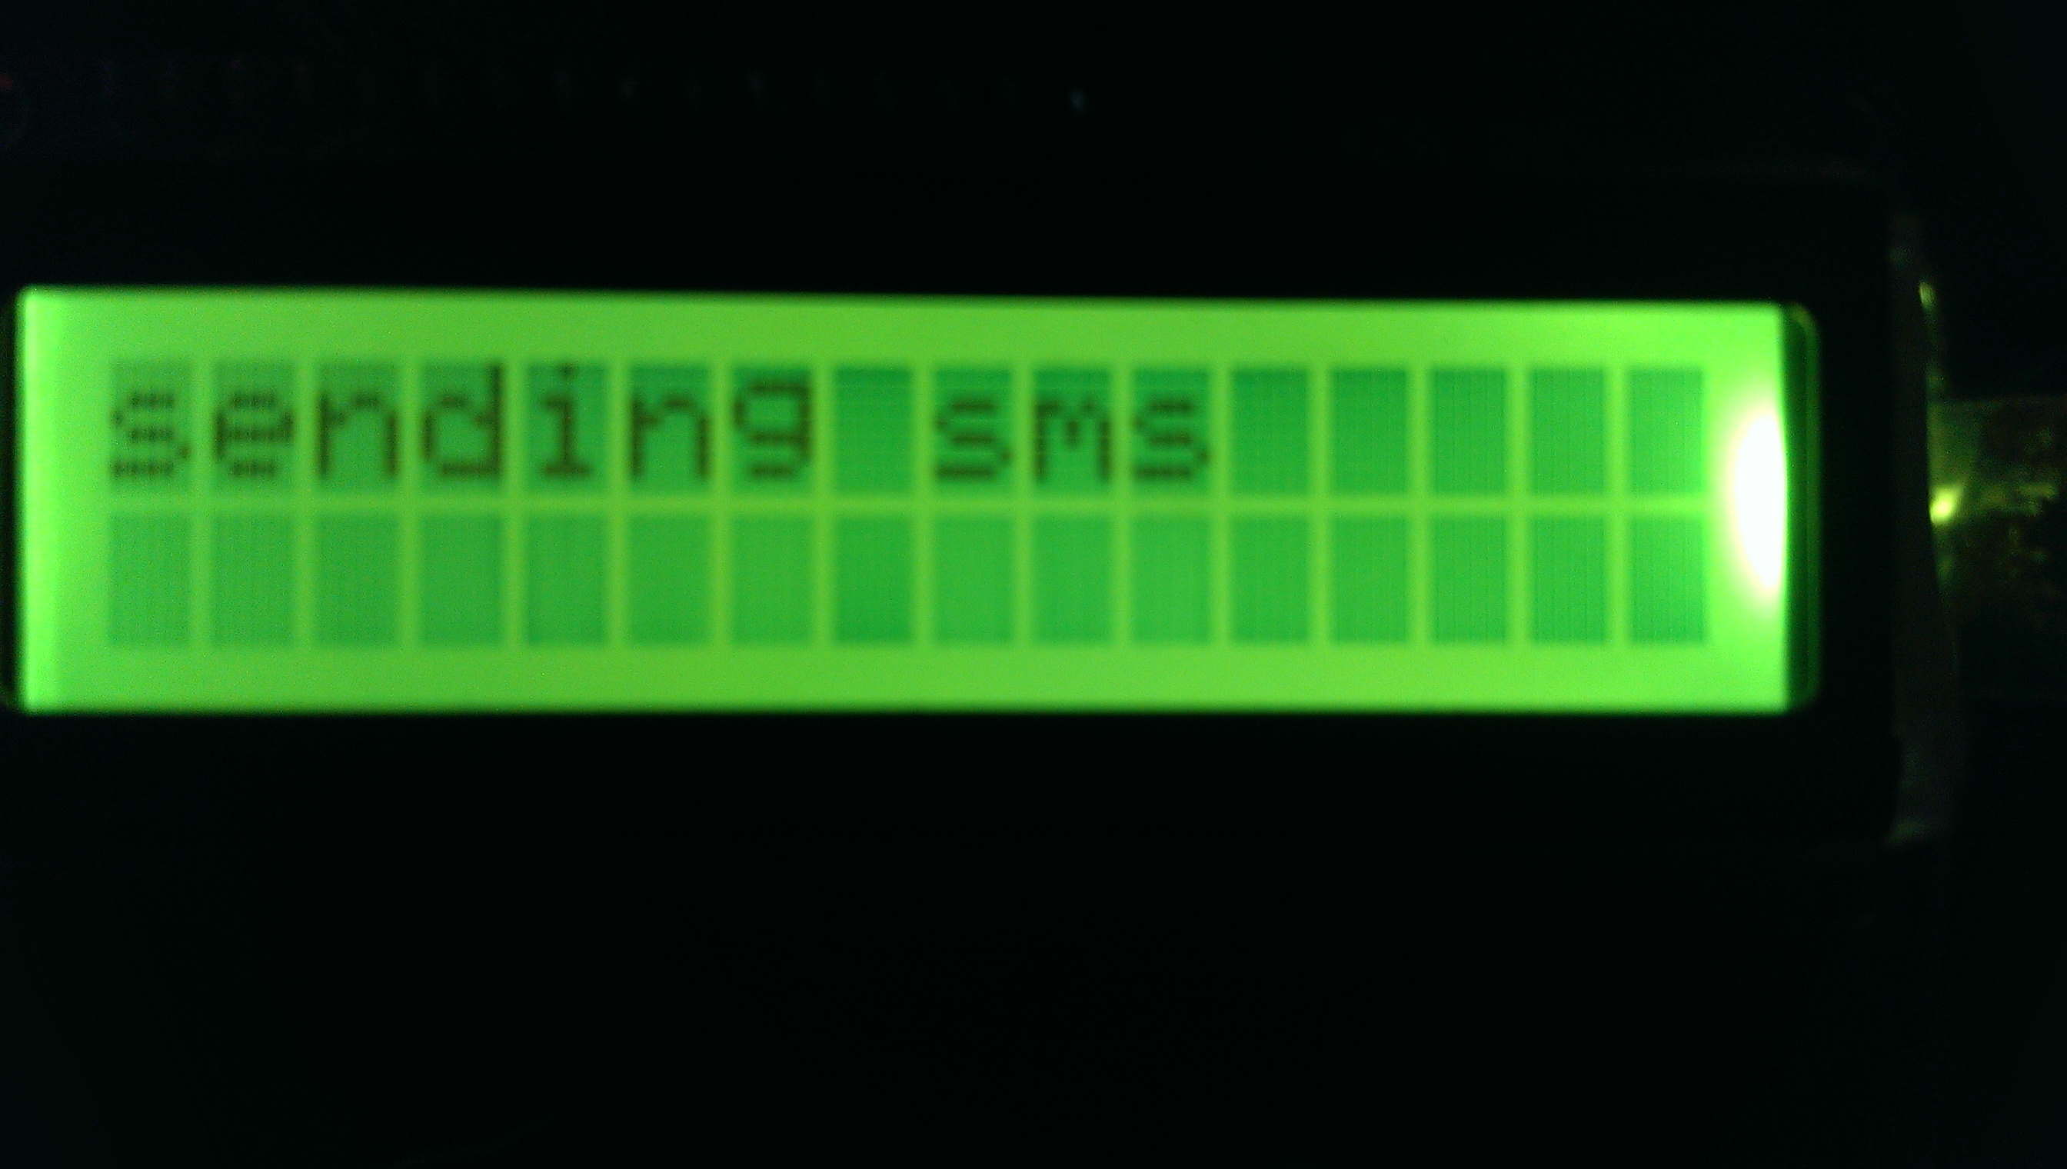

Display while Tampering:

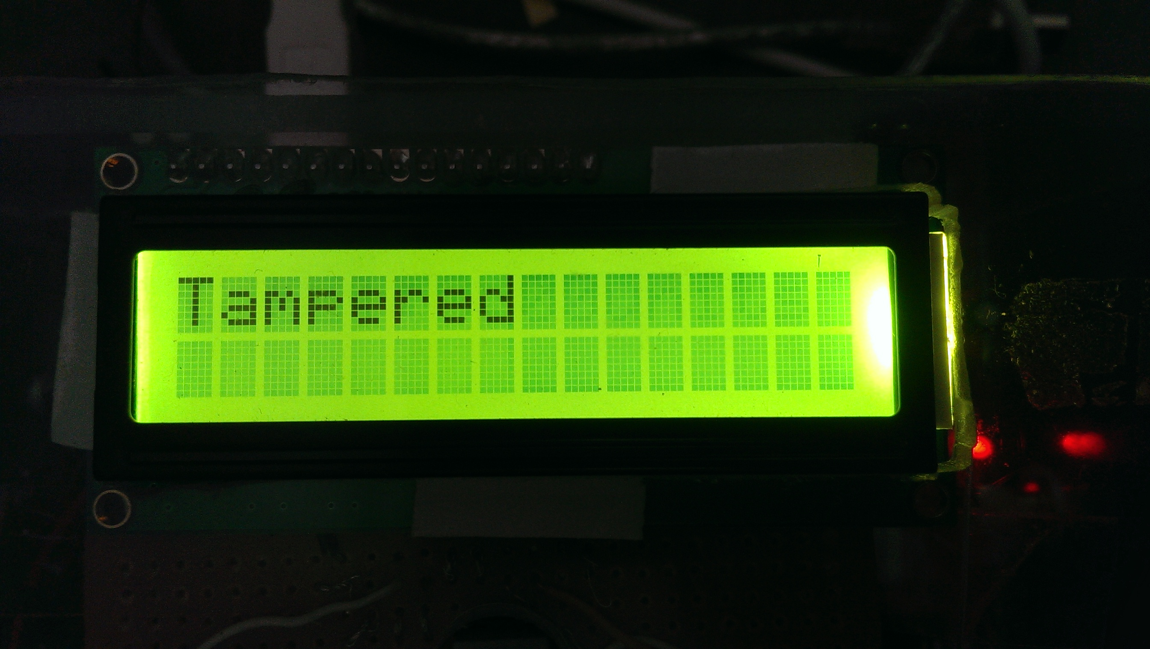

Display with Mode-1:

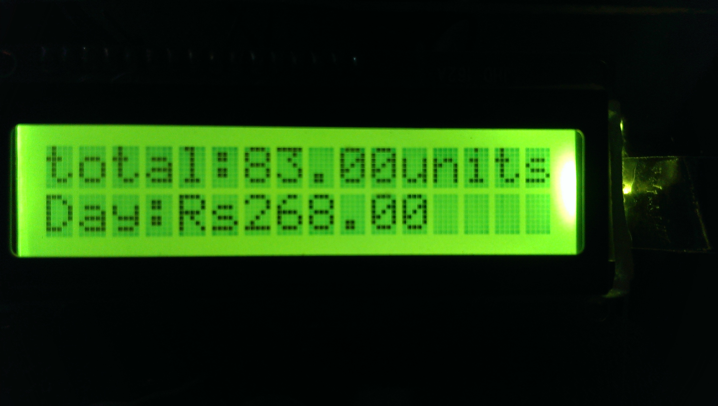

Display with Mode-2:

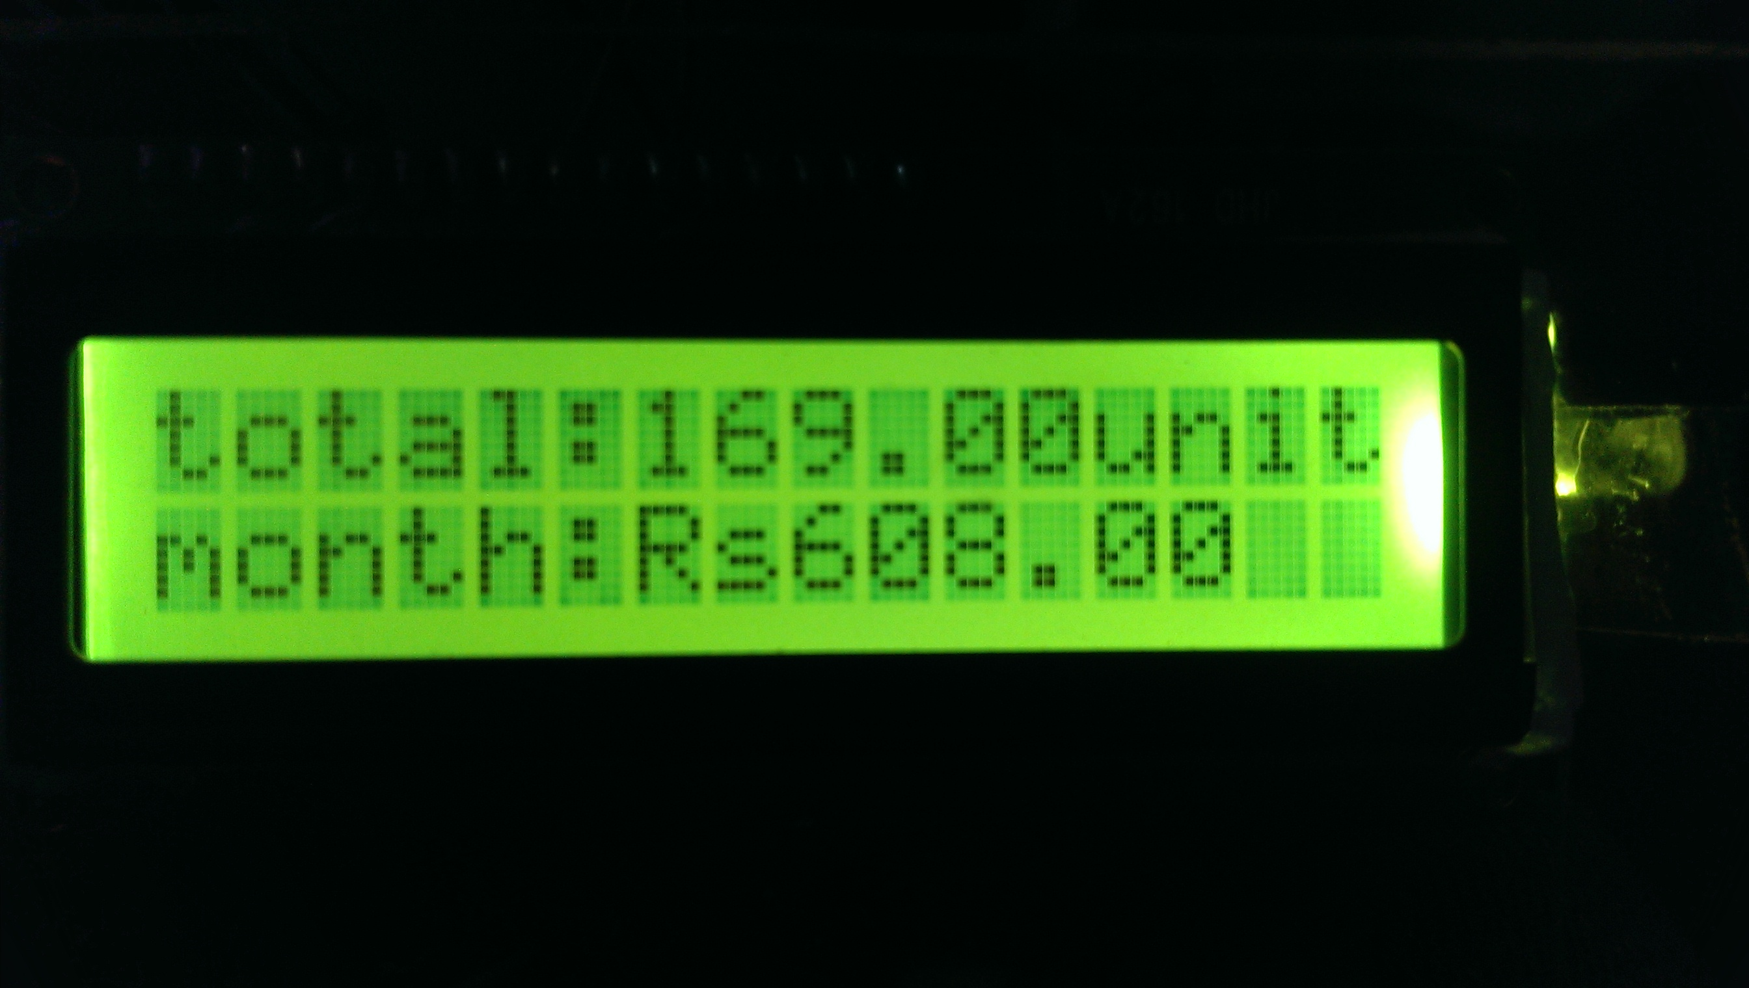

Display with Mode-3:

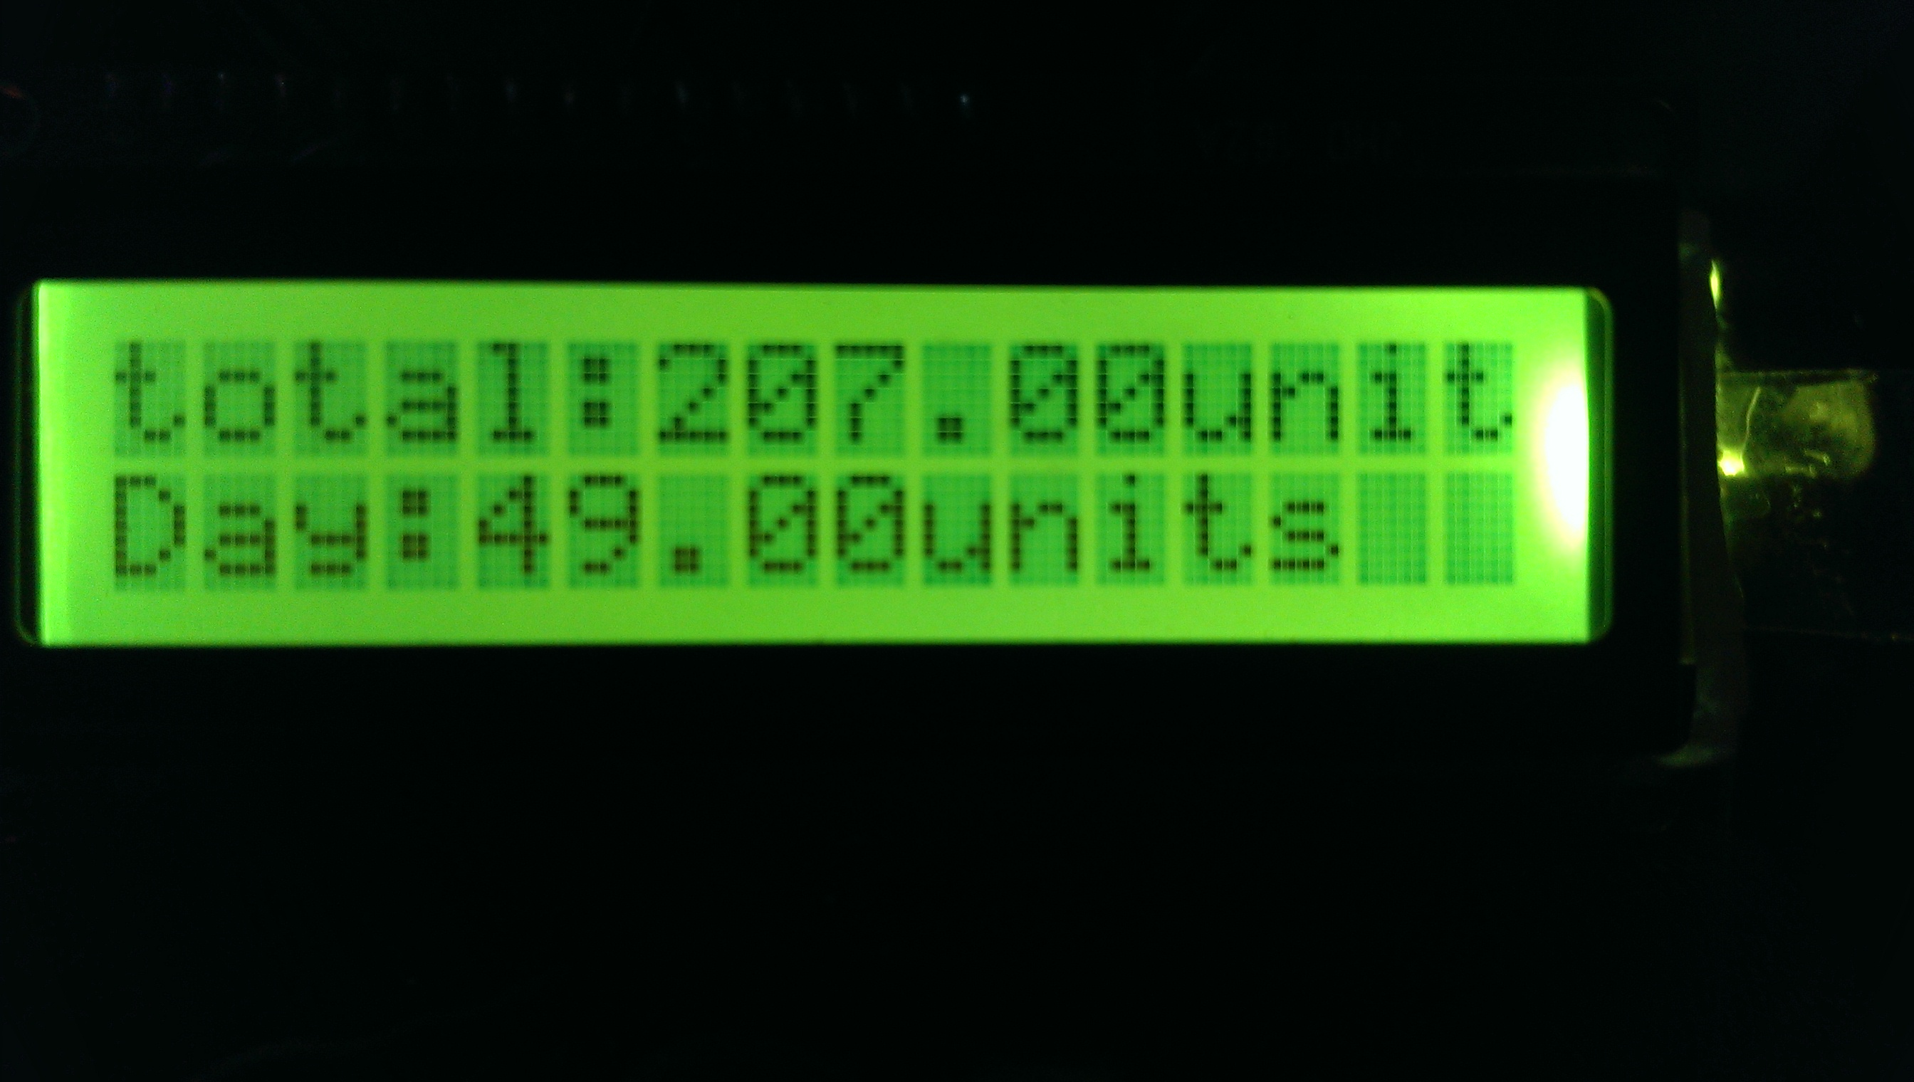

Display with Mode-4:

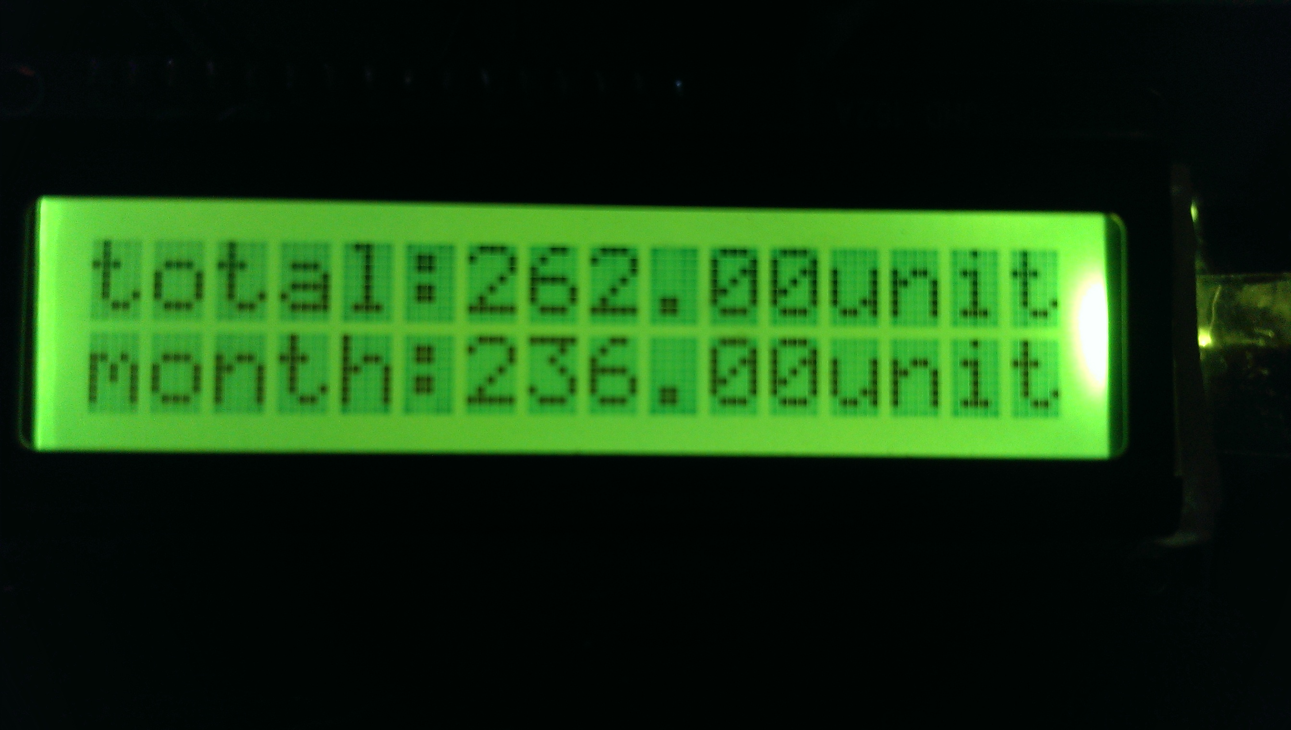

### 17. Message Formats

### Monthly bill message Format:

### 

### Tamper detection warning message format:

### 

### 18. Database

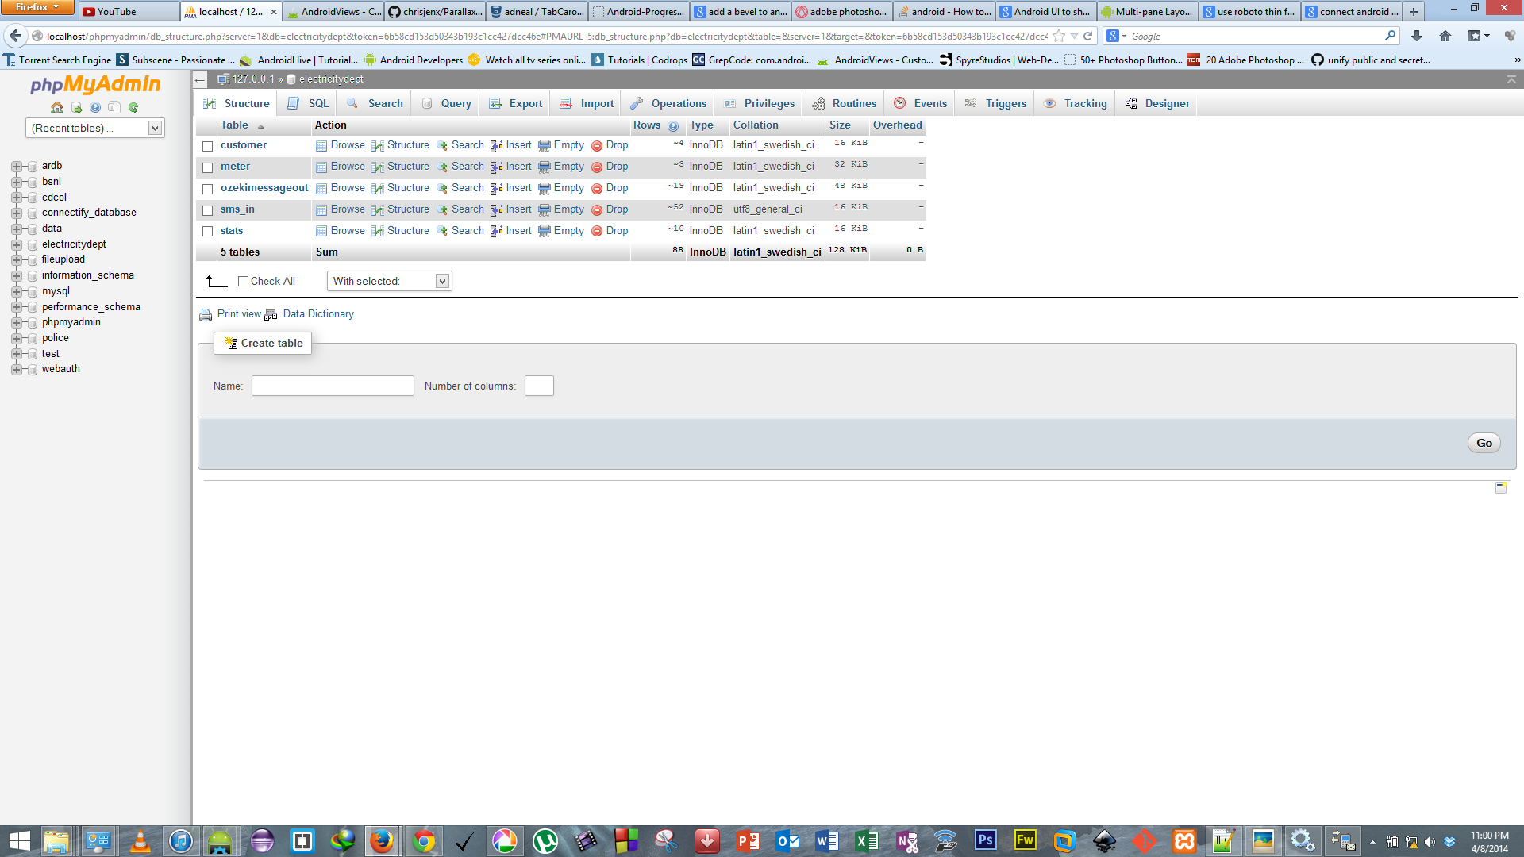

**Fig. Database Snapshot**

This is completely automated. A Database is maintained at electricity department, which will have details of each and every meter present. This Database is used for storing the usage statistics, details of the customer and other information. The statistics sent by the devices will be stored and tabulated here. SMS is also sent to the customer with the help of this database.

### 19. Android App

### For Android phone users we have provided an added advantage of a mobile app from which a user can scan his QR code provided with the device and pay his bill directly from his smart phone and he can also view his previous history by this app.

### App Icon:

### 

### Screenshots of App:

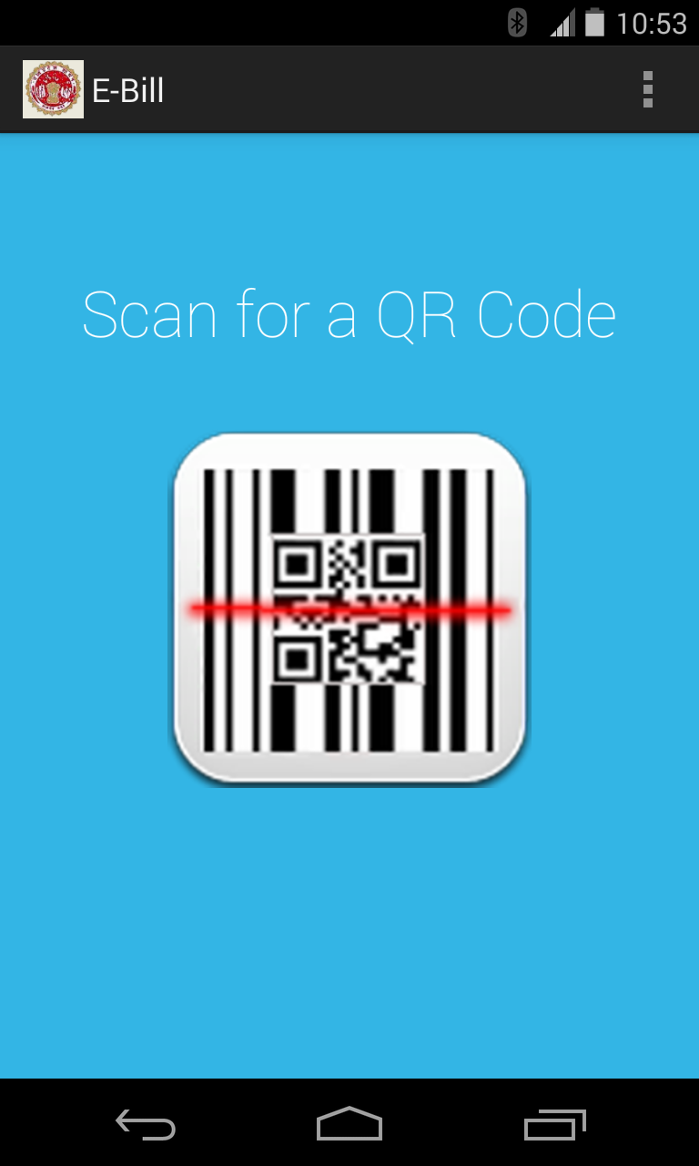 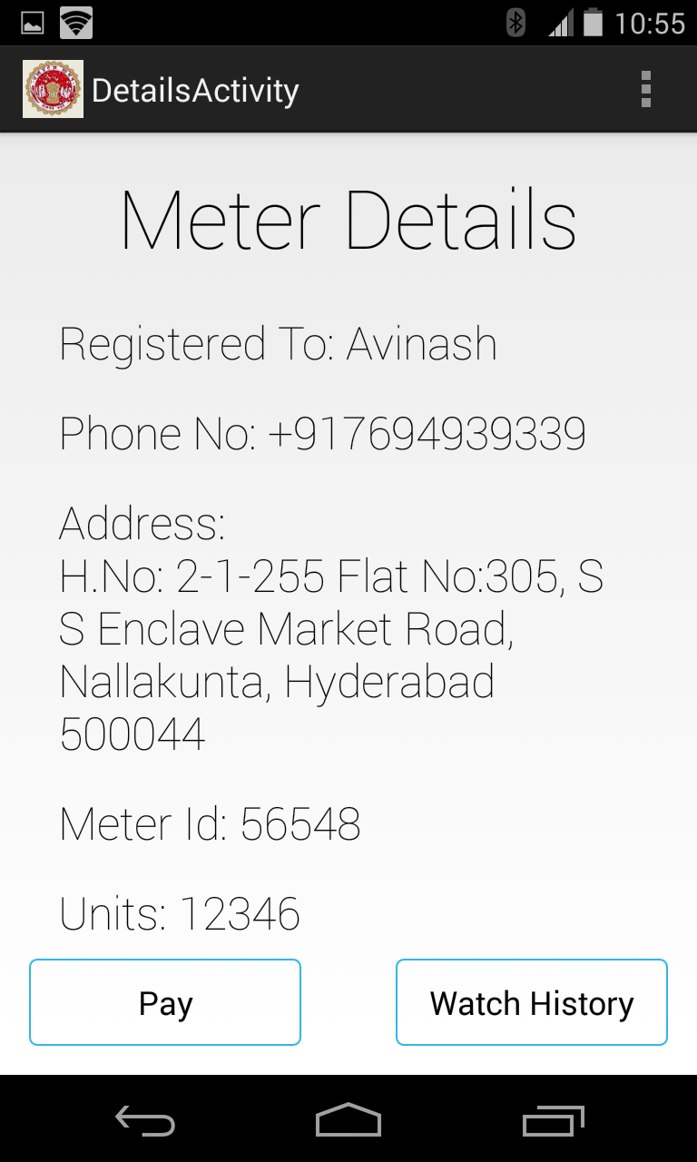

### 20. Conclusion

#### 20.1 Advantages

* It is an automated solution.
* It is more reliable solution than any other existing solution.
* Human effort is reduced.
* It sends updates of the usage (on request) to mobile of the customer.
* Statistics will be updated in electricity department’s database through GPRS.
* Auto Disconnection feature will be included also through GPRS.
* The device will be user friendly.
* Monitoring of usage can be done regularly, there by regulating their usage.
* Usage of Paper is highly reduced.

#### 20.2 Limitations

* Recurring cost will be reduced for GSM module. Because user will send a request to get updates from the device. Daily messages are no longer needed.
* One time extra costs will be levied on the customer due to installation.

#### 20.3 Scope

* We can link every meter to the ADHAAR card and we can develop a prepaid meter, which will deduct the money from the bank account linked to ADHAAR card.
* Entire device can be made more compact by using advanced integrated circuits.

### 21. References

* Survey Reported conducted in Jabalpur.
* <http://engineersgarage.com>
* <http://wikipedia.com>
* <http://www.google.com>
* <http://robokitsindia.co.in>
* <http://positronindia.in/PT006.aspx>
* <http://www.semiconductors.philips.com>
* <http://tinyurl.com/ltvo93>
* <http://www.maximintegrated.com>
* <http://www.prokdvs.com>
* <http://www.LNTEBG.com>
* <http://www.ebay.in>
* <http://www.evalta.com>

### Appendices

**Definitions, Acronyms and Abbreviations:**

LCD: Liquid Crystal Display

LED: Light Emitting Diode

GSM: Global Subscriber Module

Li-ion: Lithium ion

Li-po: Lithium polymer

GI sheet: Galvanised Iron sheet

MSB: Main Switch Board

LDR: Light Detecting Resistor

|  |
| --- |
|  |